## 

## VinHome Cleaning Services

## Software Requirement Specification

Project Code: VHCS-01

Document Code: SRS-VHCS – v0.1

**FPT University, 25-05-2023**

**Record of change**

*A - Added M - Modified D - Deleted

| **Effective Date** | **Changed Items** | **A* M, D** | **Change Description** | **New Version** |
| --- | --- | --- | --- | --- |
| 02/12/2016 | Initial | a | Add project overview |  |
|  |  |  |  |  |
|  |  |  |  |  |
|  |  |  |  |  |
|  |  |  |  |  |
|  |  |  |  |  |
|  |  |  |  |  |
|  |  |  |  |  |
|  |  |  |  |  |
|  |  |  |  |  |
|  |  |  |  |  |
|  |  |  |  |  |
|  |  |  |  |  |
|  |  |  |  |  |
|  |  |  |  |  |
|  |  |  |  |  |
|  |  |  |  |  |
|  |  |  |  |  |
|  |  |  |  |  |
|  |  |  |  |  |
|  |  |  |  |  |

**SIGNATURE PAGE**

**ORIGINATOR:** <Name> <Date>

<Position>

**REVIEWERS:** <Name> <Date>

<Position>

<Name, if it’s needed> <Date>

<Position>

**APPROVAL:** <Name> <Date>

<Position>

**TABLE OF CONTENTS**

VinHome Cleaning Services 1

Software Requirement Specification 1

**1. INTRODUCTION 6**

1.1. Purpose 6

1.2. Scope 6

1.3. Definitions, Acronyms, and Abbreviations 6

1.4. Overview 6

**2. OVERALL DESCRIPTION 8**

**3. FUNCTIONAL REQUIREMENT 12**

3.1. Use Cases Diagram 12

Web display 13

3.1 Login 13

3.2 Sign-up 15

3.3 Get services lists 18

3.4 Get services details 19

3.5 Get blog cards 20

3.6 Get blog details 22

3.7 Logout 24

3.8 Modify profile 25

3.9 View profile 27

3.10 Book new service 29

3.11 Get booking activity 32

3.12 Cancel Booking 34

3.14 Get notification 36

3.15 Check out 38

3.16 Get employee detail 41

3.17 Rating service 43

3.18 Create services 46

3.19 Modify service 48

3.20 Get customer account list 50

3.21 Get customer account detail 52

3.22 Get the employee account list 54

3.23 Get the employee account detail 56

3.24 Get all order list 58

3.25 Get order detail 60

3.26 Get all order completed list 62

3.27 Get order completed detail 64

3.28 Assign task to employee 66

3.29 Search Account 69

3.30 Disable Account 71

3.31 Get The Employee Status List 72

3.32 Update Employee Account 74

3.33 Create Employee Account 76

3.34 Create Blog 77

3.35 Update Blog 79

3.36 Get Request for task Change List 81

3.37 Get Request for Task Change Detail 83

3.38 Get A Rating Service List 85

3.39 Get Task List 86

3.40 Get Task Details 88

3.41 Request to cancel booking 89

3.42 Update Working Progress 91

3.43 Get Task Activities 93

3.44 Get List Rating 95

3.45 View profile 97

3.46 Modify profile 98

3.47 Apply for task 100

3.48 Transfer task 102

**4. NON-FUNCTIONAL REQUIREMENTS 105**

4.1. Usability 105

4.2. Reliability 105

4.3. Performance 105

# INTRODUCTION

## Purpose

In recent years, the population living in Vinhomes Grand Park has been steadily increasing, especially among students from universities in Thu Duc City such as FPT University, Ho Chi Minh International University, ... Alongside this trend, there is a growing demand for apartment cleaning services, including general cleaning, air-conditioner maintenance, interior cleaning, sanitization, electric devices cleaning, and repairs.

Vinhomes Cleaning Service is the Web Application that supports customers who are looking for cleaning houses with usability, quickly. The application will allow customers to book cleaning services online and will provide an easy-to-use platform for managing their bookings.

## Scope

* Register and login: users can create account, login to manage account and do functions related to the system
* View services list: Display a list of available services for the user
* View blogs: The website has a page where users can see the list of blogs written by other users, including images and brief description about it. Users can click on blog to read it
* Book a service: the users can book the service that they want by choosing that service, fill all required information and submit
* Track order activities: users can track their service booking activities by access to activities page, each activity has its own status and detail
* Cancel order and rate service: users can cancel the order has incoming status and rate the service which order is completed
* Manage blog: users can create their own blogs, update and delete them
* Comment to blog: users can leave comments to blog that they read
* Dashboard: the user who login by admin role can see the detail of each order and assign employees to it
* Manage account: the user who login by manager account can manage all existing accounts
* Manage service: the user who login by manager account can create new services, update, delete and disable existing services
* Delete blog: the user who login by manager account can delete existing blogs that violate community rules
* View Dashboard and calendar: the users who login by employee account can view their tasks on dashboard and schedule of each task
* Transfer task: the users who login by employee account can request to transfer task with colleague

VinClean is the Web Application that supports customers who are looking for cleaning houses with usability, quickly. The application will allow customers to book cleaning services online and will provide an easy-to-use platform for managing their bookings.

We need an application that provides services for customers living at Vinhomes Grand Park. The application must have characterizes:

* Run on any website platform
* Written by .net and reactjs
* The user interface must be friendly and easy to use
* Features about services easy to use
* All functions must be tested

## Definitions, Acronyms, and Abbreviations

| **Acronym** | **Definition** |
| --- | --- |
| UC | Use Case |
| VHCS | VinHomes Cleaning Service |
| SRS | Software Requirement Specification |
| MTTR | Mean Time To Repair |
| Guest | A person using the application without signing in |
| User | A person using the application without signing in or has signed in |
| Customer | A person who signed in as a customer, doing web functions such as book a service, rate an ordered service, write a blog, leave a comment … |
| Employee | A person who signed in as an employee, the purpose is to check their task |
| Manager | A person who signed in as a manager, the purpose is to manage accounts, services, orders and blogs |

## Acceptance Criteria

* A manager should be able to manage all user accounts
* A manager should be able to view orders list, detail of each one and assign employees to each order
* A manager should be able to manage services and blogs
* Employees should be able to view their tasks and schedule of each one
* Employees should be able to request to transfer tasks with other employees
* Customers should be able to track their order activities and rate ordered services
* Customers should be able to comment in blogs written by others
* Guests should be able to view services and blogs
* Email used to login and signup has to have the length of 2-50 characters and end with @gmail.com
* Password has to have the length at least 8 characters, contain 1 uppercase and at least 1 lowercase, does not contain special characters
* In book a service: Specified service has to be selected, first name and last name have to be strings of text, phone number has to be a string of 10 numbers beginning with 0, selected date has to be current or future date, selected time has to be in 7 A.M to 8 P.M, address has to be in right format of S{d}.0{d} {4d} (ex: S2.05 1210)
* In order activities: only order has status “Completed” can be checked out and rated, only order has status “Incoming” can be canceled
* Service has to have name, image, specific services and specific price of each one

## Overview

The next chapter, the Overall Description, of this document provides an overview of the product's functionality. It describes the informal requirements and is used to establish the context for the specification in the next chapter.

The third chapter, the Functional Requirements section, of this document is written to describe the functionality of the product in technical terms including its use-cases and details.

The fourth chapter, the Non-functional Requirements section, of this document is written to describe in detail the non-functionality of the product, defining how a system should look like.

The last chapter, is the Supporting Information section, of this document provides the supporting information that makes the SRS easier to use. It includes:

- Table of contents

- Index

- Appendices and be considered part of the requirements or not.

# OVERALL DESCRIPTION

**2.1 Product Overview**

2.1.1 Guest Requirements

Guests are people who have not been authenticated to the system. They only have limited access the following functions:

* Sign up
* Get services list
* Get services detail
* Get blog detail

2.1.2 Customer Requirements

Members are people who have logged in to the VinClean website with the “Customer” role. They can use the following functions:

* Login, logout
* View Profile
* Modify Profile
* Book services
* Rating services
* Get point award

2.1.3 Employee Requirements

Members are people who have logged in to the task board website with “Employee” role. They can use the following functions:

* Login, logout
* Get profile statistic
* Modify profile
* Get tasks lists
* Request change task

2.1.4 Admin Requirements

Members are people who have logged in to the admin dashboard website with “Admin” role. They can use the following functions:

* Login, logout
* Manage users
* Manage services
* Manage blog

**2.3 User characteristics**

* Guest: person who just view services but not choose to services to book
* Customer: person who can choose services to book
* Employee: person who receive and do services
* Manager: person who manage account (admin)

**2.4 Constraints**

* RESTful is an architecture that utilizes the HTTP protocol to design APIs for web applications.
* Words are combined without spacing and written in lowercase with camel case notation for variables.
* Methods and functions should have comments for easy maintenance by programmers.
* Comments should appear before methods, loops, and long code blocks.
* Design must comply with web standards, and JavaScripts and CSS must be encoded in a specific way.

**2.5 Assumptions and dependencies**

* Audience: The application assumes that the user already has enough computer knowledge to use the application effectively.
* Internet connection: To use the application, the user's computer must have an active internet connection. This allows access to the internet server where the application is hosted and allows interaction with external services or data sources.
* English language: The user interface of the application is provided in English. This requires the user to be able to read and understand English to interact with and use the app's features.
* Operating system and web browser: The application assumes that the user's computer runs a compatible operating system and has a compatible web browser to access and use the application. (MacOS, window, linux).
* Security and privacy: The application may request access to certain resources or information on the user's computer, such as personal information or photos. Assume that the user has granted and allowed the application access to these permissions.
* Regulations and policies: Users must comply with the rules, policies and terms of use of the application. This may include ensuring compliance with intellectual property rights, not using the application for illegal or harmful purposes.

**2.6 Use Case**

| ID | UseCase | Primary Actor | Secondary Actor |
| --- | --- | --- | --- |
| UC-01 | Sign-up | Guest |  |
| UC-02 | Login | Guest,Customer,Employee, Manager |  |
| UC-03 | Logout | Customer, Employee, Manager |  |
| UC-04 | Get services details | Guest, Customer |  |
| UC-05 | Get blog cards | Guest, Customer |  |
| UC-06 | Get blog details | Guest, Customer |  |
| UC-07 | Get blog comments | Guest, Customer |  |
| UC-08 | Get blog list | Manager |  |
| UC-09 | Create blog | Manager |  |
| UC-10 | Update blog | Manager |  |
| UC-11 | View customer profile | Customer |  |
| UC-12 | Modify customer account | Customer |  |
| UC-13 | View employee profile | Employee |  |
| UC-14 | Modify employee profile | Employee |  |
| UC-15 | Create new booking | Customer |  |
| UC-16 | Get booking activities | Customer |  |
| UC-17 | Cancel booking | Customer |  |
| UC-18 | Get email notification | Customer, Employee |  |
| UC-19 | Check out | Customer |  |
| UC-20 | Get employee detail | Customer |  |
| UC-21 | Rating services | Customer |  |
| UC-22 | Create services | Manager |  |
| UC-23 | Update services | Manager |  |
| UC-24 | Get customer account list | Manager |  |
| UC-25 | Get customer account detail | Manager |  |
| UC-26 | Get the Employee account list | Manager |  |
| UC-27 | Get Employee account detail | Manager |  |
| UC-28 | Get all booking list | Manager |  |
| UC-29 | Get booking details | Manager |  |
| UC-30 | Get all booking completed list | Manager |  |
| UC-31 | Get booking completed detail | Manager |  |
| UC-32 | Assign task to Employee | Manager |  |
| UC-33 | Search accounts | Manager |  |
| UC-34 | Disable Accounts | Manager |  |
| UC-35 | Get the Employee status list | Manager |  |
| UC-36 | Update Employee account | Manager |  |
| UC-37 | Create Employee account | Manager |  |
| UC-38 | Get request for task change list | Manager |  |
| UC-39 | Get change task request detail | Manager |  |
| UC-40 | Get a rating services list | Manager |  |
| UC-41 | Get employee location | Manager |  |
| UC-42 | Get task list | Employee |  |
| UC-43 | Get task detail | Employee |  |
| UC-44 | Request to cancel task | Employee |  |
| UC-45 | Update working progress | Employee |  |
| UC-46 | Get task activities | Employee |  |
| UC-47 | Get rating list | Manager |  |
| UC-48 | Apply for task | Employee |  |
| UC-49 | Transfer task | Employee |  |

# FUNCTIONAL REQUIREMENT

## 1. Use Case Diagram

### 1.1. VinClean Use Case Diagram

## 

*Figure 1: VinClean Use Case Diagram*

### 1.2. Admin

## 

*Figure 2: Admin Use Case Diagram*

## 

## 

## 

## 2. Web display

### 2.1. Screen Flow

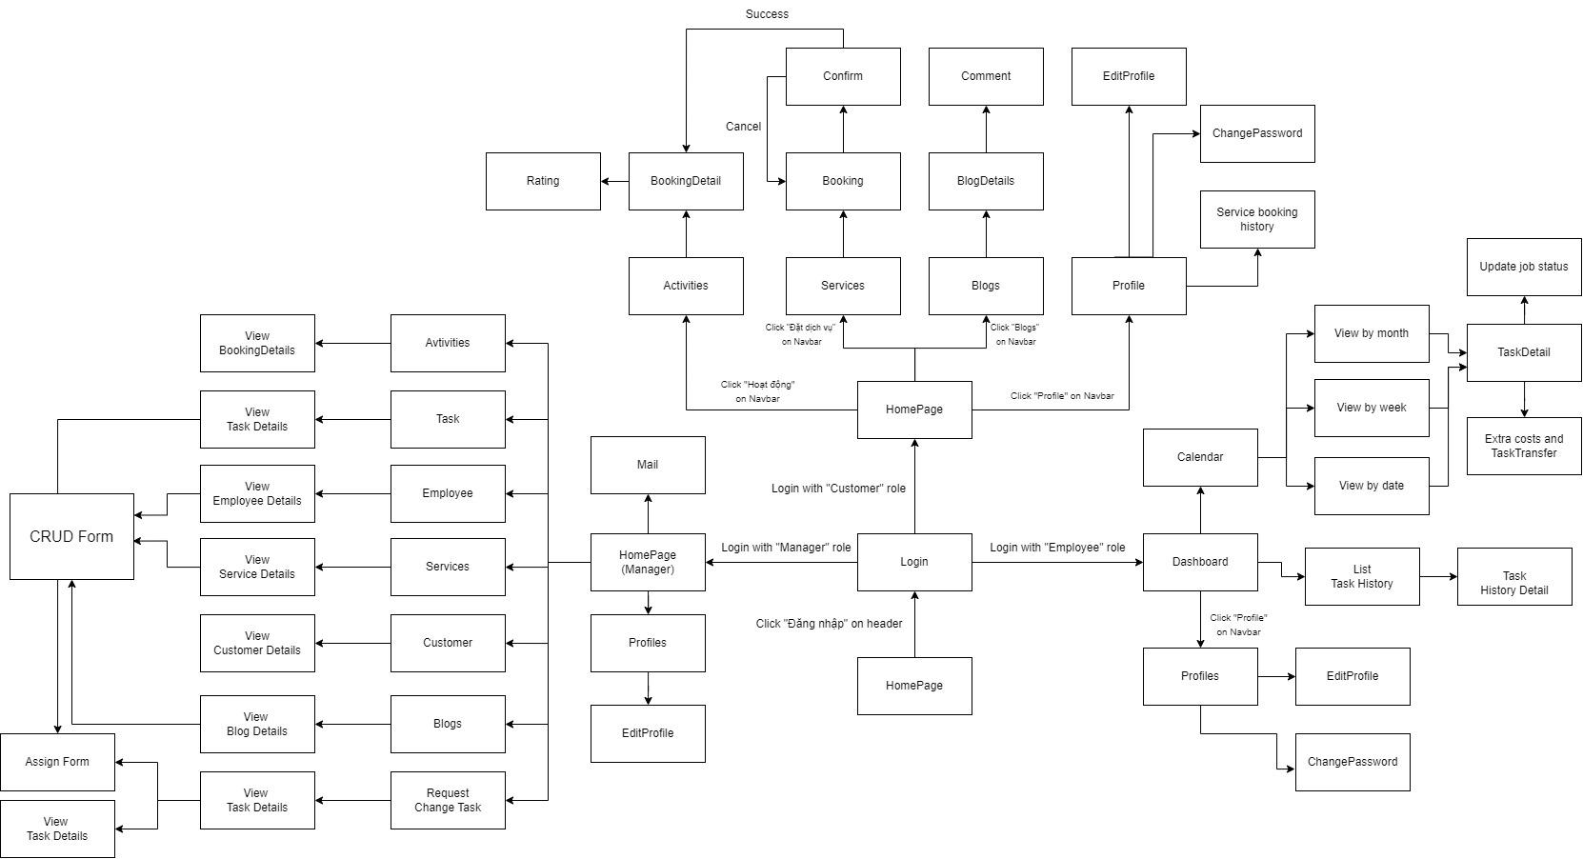

### 2.2. Screen Description

### 

| ID | **Feature** | **Screen** | **Description** |
| --- | --- | --- | --- |
| 01 | Log in | Login | Login by email or account |
| 02 | Sign up | Sign up | Create a new account as public |
| 03 | Get services list | Services | Gives each type of service for the actor to choose |
| 04 | Get services details | Services | Provides a clear information about the service like description, cost, slot, etc. to the actor |
| 05 | Get blog cards | Blogs | Overviews blogs and displays them in the blog page for the actor |
| 06 | Get blog details | Blogs | Redirects the actor to the blog chosen by the actor to read |
| 07 | Log out |  | Log out of current account |
| 08 | Modify account | Profiles | Edit personal information of current account |
| 09 | View profile | Profiles | View personal information of account |
| 10 | Create new booking | Booking | Create a new service booking |
| 11 | Get booking activities |  | View all bookings of activities |
| 12 | Cancel booking | Booking | Cancel booking |
| 14 | Get notification |  | Receive notifications about cleaning, maintenance, and repair services. |
| 15 | Use point award | Booking | Use points for service discounts |
| 16 | Get employee details | Booking, BookingHistory | View staff information |
| 17 | Rating services | BookingHistory | Evaluate staff by using star rating |
| 18 | Create services | Manage services | Create new a service |
| 19 | Modify services | Manage services | Edit existing services in the system |
| 20 | Get customer account list | Manage customer | View list of customer account |
| 21 | Get customer account detail | Manage customer | View all detail of customer account |
| 22 | Get the Employee account list | Manage Employee | View list of employee account |
| 23 | Get Employee account detail | Manage Employee | View all detail of employee account |
| 24 | Get all booking list | Manage booking | View lists of booking order |
| 25 | Get booking detail | Manage booking | View all detail of booking order |
| 26 | Get all booking completed list | Manage booking | View all list of booking order after finished |
| 27 | Get booking completed detail | Manage booking | View all detail of booking order after finished |
| 28 | Assign task to Employee | Manage task | Assign tasks to employees |
| 29 | Search accounts | Manage account | Search accounts including staff and customer account |
| 30 | Disable Accounts | Manage account | Stop activity on account |
| 31 | Get the Employee status list | Manager Employee | View a status list of employee account |
| 32 | Update Employee account | Manager Employee | Update new information for employee accounts |
| 33 | Create Employee account | Manager Employee | Create a new employee account |
| 34 | Create blog | Manage blog | Create a new blog |
| 35 | Update blog | Manage blog | Update a blog |
| 36 | Get request for job change list | Manager | View the list of changed task requirements |
| 37 | Get change jobs request detail | Manager | View information in detail request of change job |
| 38 | Get a rating services list | Manage services | View all ratings list of customers |
| 39 | Get task list | TaskList | View a list of tasks |
| 40 | Get task detail | TaskDetails | View a detail of tasks |
| 41 | Request to cancel task | TaskDetails | Cancel a booking that is in progress or scheduled within the system |
| 42 | Update working progress | TaskDetails | Update the progress of their assigned tasks in the system |
| 43 | Get task activities | TaskList | Retrieve a list of activities associated with their assigned task |
| 44 | Get rating list | TaskDetails | View ratings and comments provided by users regarding their services |
| 45 | View profile | Profiles | View employee profile |
| 46 | Modify profile | Profile | Edit employee profile |
| 47 | Apply for task | TaskDetails | Apply for their Task |
| 48 | Transfer task | TaskDetails | Allows the 2 employees to exchange work with each other |
| 49 | Get task list | Calendar | View a list of tasks (view by date, week, month) |
| 50 | Get task activities | Dashboard | Retrieve a list of activities associated with their assigned task |

### 2.3. User Authorization

| **Screen** | **Guest** | **Customer** | **Employee** | **Manager** |
| --- | --- | --- | --- | --- |
| **<<Screen authentication>>** |  |  |  |  |
| Login | x | x | x | x |
| Sign up | x |  |  |  |
| Log out |  | x | x | x |
| **<<Screen View Service>>** |  |  |  |  |
| Get services list | x | x | x | x |
| Get services details | x | x |  | x |
| **<<Screen Booking>>** |  |  |  |  |
| Create new booking |  | x |  |  |
| Get booking activities |  | x | x | x |
| Cancel booking |  | x | x |  |
| Payment |  | x |  |  |
| Use point award |  | x |  |  |
| Get employee details |  | x |  | x |
| Rating services |  | x |  |  |
| **<<Screen Blogs>>** |  |  |  |  |
| Get blog cards | x | x |  | x |
| Get blog details | x | x |  | x |
| Create blog |  |  |  | x |
| Update blog |  |  |  | x |
| **<<Screen Profiles>>** |  |  |  |  |
| View profiles |  | x | x | x |
| Modify profiles |  | x | x | x |
| **<<Screen Manage Service>>** |  |  |  |  |
| Create services |  |  |  | x |
| Modify services |  |  |  | x |
| Get a rating services list |  |  |  | x |
| **<<Screen Account>>** |  |  |  |  |
| Get customer account list |  |  |  | x |
| Get customer account details |  | x |  | x |
| Get the Employee account list |  |  |  | x |
| Get Employee account detail |  |  | x | x |
| Search accounts |  |  |  | x |
| Disable Accounts |  |  | x | x |
| Create Employee account |  |  |  | x |
| Update Employee account |  |  | x | x |
| **<<Screen Task>>** |  |  |  |  |
| Get task list |  |  | x | x |
| Get task details |  |  | x | x |
| Request to cancel task |  |  | x |  |
| Update task progress |  |  | x |  |
| Apply for task |  |  | x |  |
| Transfer task |  |  | x |  |
| Get rating list |  |  |  | x |
| Get task activities |  |  | x | x |
| Get request for task change list |  |  |  | x |
| Get change task request detail |  |  | x | x |
| Calendar |  |  | x |  |
| Dashboard |  |  | x |  |

## 3. Use Case Description

## 3.1 Sign-up

| **USE CASE-02 Sign-up** | | | | |
| --- | --- | --- | --- | --- |
| **Use-case No.** | UC002 | **Use-case Version** | | <1.0> |
| **Use-case Name** | Sign-up | | | |
| **Author** | CuongNQ | | | |
| **Date** | 11/06/2023 | **Priority** | <Normal> | |
| **Actor:**  Guest  **Summary:**  This feature allows the actor to create a new account as public  **Goal:**  A new account was created successfully  **Triggers**  The actor wants to create a new account for login  **Preconditions:**   * Actor has to be on login page * On login page, the actor clicks “Đăng ký” to create a new account   **Post Conditions:**   * System creates a new account and stores it in the database.   **Main Success Scenario:**   | **Step** | **Actor Action** | **System Response** | | --- | --- | --- | | **1** | In sign-in page, actors clicks on “Đăng ký” button | System redirects to sign-up page with a form:   * Username: A string can’t be identical * Password: A String contains at least 8 characters * Confirm password: A string must be identical to password * Phone number: A string of number having 9-11 characters | | **2** | Actor fills all attributes in the form | [Exception] | | **3** | Actor clicks “Đăng ký” | System checks input information:   * Valid: system create new account and redirects to login page * Invalid: System shows error message according to wrong filled attribute. |   **Alternative Scenario:**  N/A  **Exceptions:**  [Exception 1]   | **No** | **Cause** | **System Response** | | --- | --- | --- | | **1** | Username has already existed | System requests the actors to enter the password in the right form | | **2** | Invalid password | System requests the actor to enter password in the right format | | **3** | Confirm password does not match password | System informs that the confirm password must match the password | | **4** | Phone number has been assigned to another account | System informs that the phone number has been used and requires another phone number |   **Assumption:**   * Actor’s internet connection is available   **Business Rules:**   * Username does not exist before * Password must not be empty and contains at least 8 characters * Password and confirm password must match to each other * Phone number has not been assigned to any account before. | | | | |

## 3.2 Login

| **USE CASE-01 Login** | | | | |
| --- | --- | --- | --- | --- |
| **Use-case No.** | UC001 | **Use-case Version** | | <1.0> |
| **Use-case Name** | Login | | | |
| **Author** | CuongNQ | | | |
| **Date** | 11/06/2023 | **Priority** | <High> | |
| **Actor:**  Customer, Manager, Employee  **Summary:**  This feature allows the actor to login to the system to use features related to each role  **Goal:**  Actor logs into account successfully and can use web’s features  **Triggers**  The actor wants to login to the website so that Actor can use the specific features.  **Preconditions:**   * The actor has a signed-up account * The actor clicks on “Tài khoản” on the navigation bar * The actor enters the correct username and password   **Post Conditions:**   * System logs the actor into the account and redirects to the homepage.   **Main Success Scenario:**   | **Step** | **Actor Action** | **System Response** | | --- | --- | --- | | **1** | Actor clicks on “Đăng nhập” on navigation bar | System redirects the actor to login page and shows the login form which has:   * Username: A string can’t be identical * Password: A string contains at least 8 characters * Login button | | **2** | Actor enters username and password | [Exception] | | **3** | Actor clicks “Đăng nhập” button | System checks input information:   * Valid: System logs the actor into account and redirects to homepage * Invalid: System shows error message “Incorrect username or password” |   **Alternative Scenario:**   | **Step** | **Actor Action** | **System Response** | | --- | --- | --- | | **1** | Actor chooses login via Google | System shows the list of Google accounts of User | | **2** | Actor chooses the account to login | System logs the user into account and redirects to homepage |   **Exceptions:**  [Exception 1]   | **No** | **Cause** | **System Response** | | --- | --- | --- | | **1** | Actor enters wrong username or password | System responses with a message “Incorrect username or password” |   **Assumption:**   * Actor’s internet connection is available * Actor has signed-up account or Google account   **Business Rules:**   * Username must not be empty * Password must not be empty and contain at least 8 characters * The actor has to wait for 5 minutes when fail to login 5 times | | | | |

## 3.3 Logout

| **USE CASE-07 Logout** | | | | |
| --- | --- | --- | --- | --- |
| **Use-case No.** | UC007 | **Use-case Version** | | <1.0> |
| **Use-case Name** | Logout | | | |
| **Author** | CuongNQ | | | |
| **Date** | 11/06/2023 | **Priority** | <Low> | |
| **Actor:**  Customer, Employee, Manager  **Summary:**  When actor clicks on “Đăng xuất” in the account, the system logs the actor out of current account  **Goal:**  Let the actor log out of his/her current account.  **Triggers**  The actor wants to log out of the account  **Preconditions:**   * The actor already logged in to the account * The actor clicks on “Đăng xuất”   **Post Conditions:**   * Actor exits current account.   **Main Success Scenario:**   | **Step** | **Actor Action** | **System Response** | | --- | --- | --- | |  | On homepage, actor hovers over the user name displayed on the navigation bar | A dropdown list is is shown to the actor, which contains:   * Profile * Activities * Notification * Logout | | **1** | Actor clicks “Đăng xuất” in the dropdown list. | System exits the actor from the current account and redirects to homepage |   **Alternative Scenario:**  N/A  **Exceptions:**  N/A  **Assumption:**   * Actor’s internet connection is available * Actor has to login to account   **Business Rules:**   * All features that can only be used when login are disabled after logout * The current session is deleted | | | | |

|  | | | | |
| --- | --- | --- | --- | --- |
|  |  |  | |  |
|  |  | | | |
|  |  | | | |
|  |  |  |  | |
|  | | | | |

## 3.3 Get services lists

| **USE CASE-03 Get Services lists** | | | | |
| --- | --- | --- | --- | --- |
| **Use-case No.** | UC003 | **Use-case Version** | | <1.0> |
| **Use-case Name** | Get service list | | | |
| **Author** | CuongNQ | | | |
| **Date** | 11/06/2023 | **Priority** | <High> | |
| **Actor:**  Customer, Guest  **Summary:**  This feature gives each type of service for the actor to choose  **Goal:**  List of services is given to the actor  **Triggers**  The actor wants to know what type of services Actor can choose  **Preconditions:**   * The actor has to be on service page   **Post Conditions:**   * List of services is shown to the actor.   **Main Success Scenario:**   | **Step** | **Actor Action** | **System Response** | | --- | --- | --- | | **1** | Actor clicks on “Dịch vụ” on the navigation bar | System redirects to services page and show list of services, each one has:   * Service image * Service name * Duration * Price * Rate * Button “Xác nhận”   [Exception] |   **Alternative Scenario:**  N/A  **Exceptions:**  N/A  **Assumption:**   * Actor’s internet connection is available   **Business Rules:**  N/A | | | | |

## 3.4 Get services details

| **USE CASE-04 Get Services Details** | | | | |
| --- | --- | --- | --- | --- |
| **Use-case No.** | UC004 | **Use-case Version** | | <1.0> |
| **Use-case Name** | Get service details | | | |
| **Author** | CuongNQ | | | |
| **Date** | 11/06/2023 | **Priority** | <High> | |
| **Actor:**  Customer, Guest  **Summary:**  This feature provides a clear information about the service like description, cost, slot, etc. to the actor  **Goal:**  Actor knows clearly about the service.  **Triggers**  The actor wants more information about the service  **Preconditions:**   * The actor has to be on service page * Actor choose a service to view its detail   **Post Conditions:**   * Details of service are shown to the actor.   **Main Success Scenario:**   | **Step** | **Actor Action** | **System Response** | | --- | --- | --- | | **1** | Actor clicks on “Dịch vụ” on navigation bar to get to service page | System redirects to services page and show list of services with details:   * Service name * Duration * Price | | **2** | On one of services, actor clicks on “Xác nhận” | System redirects to that service page which contains the service's description at the left side and a form for the actor to book that service at the right side  [Exception] |   **Alternative Scenario:**  N/A  **Exceptions:**  [Exception 1]   | **No** | **Cause** | **System Response** | | --- | --- | --- | | **1** | Time out | Service detail is not displayed to the actor |   **Assumption:**   * Actor’s internet connection is available   **Business Rules:**  N/A | | | | |

## 3.5 Get blog cards

| **USE CASE-05 Get blog cards** | | | | |
| --- | --- | --- | --- | --- |
| **Use-case No.** | UC005 | **Use-case Version** | | <1.0> |
| **Use-case Name** | Get blog cards | | | |
| **Author** | CuongNQ | | | |
| **Date** | 11/06/2023 | **Priority** | <Normal> | |
| **Actor:**  Guest, Customer  **Summary:**  The systems overviews blogs and displays them in the blog page for the actor  **Goal:**  Actor sees an overview of each blog to decide what to read.  **Triggers**  The actor wants to see blogs of the page  **Preconditions:**   * The actor has to access to blog page   **Post Conditions:**   * System shows overviews of blogs to the actor.   **Main Success Scenario:**   | **Step** | **Actor Action** | **System Response** | | --- | --- | --- | | **1** | Actor clicks on “Blogs” on navigation bar | System redirects to blog overviews page, each blog has:   * Blog image * Published date * Title * Brief summary * “Xem thêm” button to go to that blog page |   **Alternative Scenario:**  N/A  **Exceptions:**  N/A  **Assumption:**   * Actor’s internet connection is available   **Business Rules:**  N/A | | | | |

## 

## 

## 

## 3.6 Get blog details

| **USE CASE-06 Get blog details** | | | | |
| --- | --- | --- | --- | --- |
| **Use-case No.** | UC006 | **Use-case Version** | | <1.0> |
| **Use-case Name** | Get blog details | | | |
| **Author** | CuongNQ | | | |
| **Date** | 11/06/2023 | **Priority** | <Normal> | |
| **Actor:**  Guest, Customer  **Summary:**  The system redirects the actor to the blog chosen by the actor to read  **Goal:**  Actors can read, rate and write the comment to the blog that Actor chooses.  **Triggers**  The actor wants to read the blog  **Preconditions:**   * The actor has to access to blog page * The actor has to choose a blog to read   **Post Conditions:**   * **Success:** System redirects the actor to the chosen blog.   **Main Success Scenario:**   | **Step** | **Actor Action** | **System Response** | | --- | --- | --- | | **1** | Actor clicks on “Blogs” on navigation bar to get to blog page | System redirects the actor to blog page and shows blog overviews | | **2** | Actor chooses a blog on blog page to read | System redirects the actor to that blog which displays:   * Blog title * Author * Published date * Modified date * Blog details * Rating star * Comment   [Exception] |   **Alternative Scenario:**  N/A  **Exceptions:**  [Exception]   | **No** | **Cause** | **System Response** | | --- | --- | --- | | **1** | Timeout | Blog detail is not displayed to the actor | | **2** | Blog was deleted | System redirects 404 page |   **Assumption:**   * Actor’s internet connection is available   **Business Rules:**  N/A | | | | |

## 3.7 Get blog comments

## 3.8 Get blog list

## 3.9 Create blog

| **USE CASE-33 Create blog** | | | | |
| --- | --- | --- | --- | --- |
| **Use-case No.** | UC034 | **Use-case Version** | | <1.0> |
| **Use-case Name** | Create blog | | | |
| **Author** | TungLT | | | |
| **Date** | 02/06/2023 | **Priority** | Normal | |
| **Actor:**  Manager  **Summary:**  This feature allows the actor to create a new blog.  **Goal:**  A new blog was created successfully.  **Triggers**   * The actor wants to create a new blog.   **Preconditions:**   * The actor has logged in by an Manager account. * The current screen is “Blog List” screen.   **Post Conditions:**   * **Success:** System created blog.   **Main Success Scenario:**   | **Step** | **Actor Action** | **System Response** | | --- | --- | --- | | **1** | The actors click on “Create Blog” button on “Blog list" screen. | System shows pop up showing all fields for the Manager to fill, including:   * + Header: text   + Body: text   + Image: img | | **2** | Manager fills header and body then clicks on “Submit button”. | System show “Create Successfully”.  [Exception 1] |   **Alternative Scenario:**  N/A  **Exceptions:**   | **Step** | **Actor Action** | **System Response** | | --- | --- | --- | | **1** | At least one input field is blank | System shows error message corresponding to the fail constrain. |   **Business Rules:**   * Header, Body cannot null.   **Assumptions:**   * Actor’s internet connection is available. | | | | |

## 3.10 Update blog

| **USE CASE-34 Update blog** | | | | |
| --- | --- | --- | --- | --- |
| **Use-case No.** | UC035 | **Use-case Version** | | <1.0> |
| **Use-case Name** | Update blog | | | |
| **Author** | TungLT | | | |
| **Date** | 02/06/2023 | **Priority** | Normal | |
| **Actor:**  Manager  **Summary:**  This feature allows the actor to update a blog.  **Goal:**  A blog was updated successfully.  **Triggers**   * The actor wants to update a blog.   **Preconditions:**   * The actor has logged in by an Manager account. * The current screen is “Blog detail” screen.   **Post Conditions:**   * **Success:** System display a message is “Update blog success!”.   **Main Success Scenario:**   | **Step** | **Actor Action** | **System Response** | | --- | --- | --- | | **1** | In blog detail page, actor clicks “Update” button on the lef1t the blog.  [Alternative 1] | System shows two options are:   * Update * Delete | | **2** | The Actor clicks into “Update” option. | System shows “Update blog” confirm form for the Manager to fill, including:   * Header: Text * Body: Text | | **3** | Actor clicks into “Submit” button. | System shows a message is “Update blog success!” and create this blog.  [Exception 1] |   **Alternative Scenario:**     | **Step** | **Actor Action** | **System Response** | | --- | --- | --- | | **1** | Actor clicks into “Delete” option. | System shows a “Message box” to warn the Manager “Are you sure?” | | **2** | ActoConfirmr clicks into “Confirm” button. | System shows a message is “Delete bloDeleteg success!” and create this blog. |   **Exceptions:**     | **Step** | **Actor Action** | **System Response** | | --- | --- | --- | | **1** | At least one input field is blank | System shows error message corresponding to the fail constrain. |   **Business Rules:**   * Account just only can be updated by the Manager that created it.   **Assumptions:**   * Actor’s internet connection is available. | | | | |

## 3.8 View customer profile

| **USE CASE-09 View customer profile** | | | | |
| --- | --- | --- | --- | --- |
| **Use-case No.** | UC009 | **Use-case Version** | | <1.0> |
| **Use-case Name** | View profile | | | |
| **Author** | CuongNQ | | | |
| **Date** | 11/06/2023 | **Priority** | <Low> | |
| **Actor:**  Customer  **Summary:**  When actor clicks on “Thông tin cá nhân” on navigation bar, the system redirects Actor to his/her current account profile  **Goal:**  The account profile is shown to the actor.  **Triggers**  The actor wants to see his/her user profile  **Preconditions:**   * The actor already logged in to the account * The actor clicks on “Thông tin cá nhân” button on navigation bar   **Post Conditions:**   * System redirects to account page and shows account profile   **Main Success Scenario:**   | **Step** | **Actor Action** | **System Response** | | --- | --- | --- | | **1** | Actor clicks on account’s icon on navigation bar | System redirects to account page and shows account profile whose left side has:   * Full Name * Gender * Phone * Email * Address   The right side contains user's avatar and a button “Chỉnh sửa” to modify the account |   **Alternative Scenario:**  N/A  **Exceptions:**  N/A  **Assumption:**   * Actor’s internet connection is available * Actor has to login to account   **Business Rules:**  N/A | | | | |

## 3.9 Modify customer profile

| **USE CASE-08 Modify customer profile** | | | | |
| --- | --- | --- | --- | --- |
| **Use-case No.** | UC008 | **Use-case Version** | | <1.0> |
| **Use-case Name** | Modify profile | | | |
| **Author** | CuongNQ | | | |
| **Date** | 11/06/2023 | **Priority** | <Low> | |
| **Actor:**  Customer  **Summary:**  When actor clicks on “Chỉnh sửa” button in the profile, the system lets the actor to edit information of current account  **Goal:**  The actor is allowed to modify profile information on demand.  **Triggers**  The actor wants to update his/her user profile  **Preconditions:**   * The actor already logged in to the system.   **Post Conditions:**   * The actor clicks on “Thông tin cá nhân” button on navigation bar   **Main Success Scenario:**   | **Step** | **Actor Action** | **System Response** | | --- | --- | --- | | **1** | Actor clicks on account’s icon on navigation bar to get to profile page | System redirects the actor to profile page and shows account information | | **2** | Actor clicks “Chỉnh sửa” | System shows the form for the actor to edit account information:  On the left side has:   * Full Name: A string contains at least 1 character and can’t be identical to the current name * Gender: Male/Female (bit) * Phone: A string of number having 10 characters * Email:A string that ends with @gmail.com * Address: A string contains at least 5 characters * Date of Birth: date   On the right side has:   * Avatar container which can be clicked to choose image * button “Lưu thay đổi” | | **3** | Actor clicks “Lưu thay đổi” | New information is saved to the account and the message “Thay đổi thành công” is shown to the actor |   **Alternative Scenario:**  N/A  **Exceptions:**  [Exception 1]   | **No** | **Cause** | **System Response** | | --- | --- | --- | | **1** | Actor clicks “Hủy” | All changes are not saved and old information is remained | | **2** | Actor enter wrong information format | System does not save changes and requests the actor to enter correct format of false information |   **Assumption:**   * Actor’s internet connection is available * Actor has to login to account   **Business Rules:**   * Valid input information format | | | | |

## 3.10 View employee profile

| **USE CASE-44 View employee profile** | | | | |
| --- | --- | --- | --- | --- |
| **Use-case No.** | UC045 | **Use-case Version** | | <1.0> |
| **Use-case Name** | View profile | | | |
| **Author** | HieuNT | | | |
| **Date** | 1/06/2023 | **Priority** | <Normal> | |
| **Actor:** Employee  **Summary:**  This feature allows the actor to view their profiles.  **Goal:**  The actor can view their profiles.  **Triggers**   * The actor wants to view their profiles.   **Preconditions:**   * Actors must be logged into the system. * Actors must have the role of Employee to view their profiles.   **Post Conditions:**   * The Actor can view their profiles. * They have other option is edit and save profiles   **Main Success Scenario:**   | **Step** | **Actor Action** | **System Response** | | --- | --- | --- | | **1** | On homepage, actor hovers over the user name displayed on the navigation bar | A dropdown list is is shown to the actor, which contains:   * Profile * Logout | | **2** | Actor clicks into the “Profile” in the dropdown list. | * System shows all information of Employee:   + FullName   + Day of birth   + Address   + Contact information   + Job title |   **Alternative Scenario:**   * N/A   **Exceptions:**   * Login fail: system push a notification about error when login. * Lost connection: System displays a button to reload the page. * No account login to system   + System will redirect to login page   **Business Rules:**   * Only account logged in to the system can view their profile   **Assumptions:**   * N/A | | | | |
|  | | | | |

## 3.11 Modify employee profile

| **USE CASE-45 Modify profile** | | | | |
| --- | --- | --- | --- | --- |
| **Use-case No.** | UC046 | **Use-case Version** | | <1.0> |
| **Use-case Name** | Modify profile | | | |
| **Author** | HieuNT | | | |
| **Date** | 1/06/2023 | **Priority** | <Normal> | |
| **Actor:** Employee  **Summary:**  This feature allows the actor to modify their profiles.  **Goal:**  The actor can modify their profiles.  **Triggers**   * The actor wants to modify their profiles.   **Preconditions:**   * Actors must be logged into the system. * Actors must have the role of Employee to modify their profiles.   **Post Conditions:**   * The actor can modify and system save the   change of their profiles.  **Main Success Scenario:**   | **Step** | **Actor Action** | **System Response** | | --- | --- | --- | | **1** | On homepage, actor hovers over the user name displayed on the navigation bar | A dropdown list is is shown to the actor, which contains:   * Profile * Activities * Notification * Logout | | **2** | Actor clicks into the “Profile” in the dropdown list. | * System shows all information of actor:   + FullName   + Day of birth   + Address   + Contact information   + Job title | | **3** | Actor clicks into the “Edit” button | System allow actor to edit their profile in each field | | **4** | Actor clicks the “Save” button to save the modifications. | All information in the DataBase will be updated. |   **Alternative Scenario:**   * N/A   **Exceptions:**   * Login fail: system push a notification about error when login. * Lost connection: System displays a button to reload the page. * No account login to system   + System will redirect to login page   **Business Rules:**   * Only account logged in to the system can modify their profile   **Assumptions:**   * N/A | | | | |
|  | | | | |

## 

## 3.10 Book new service

| **USE CASE-10 Book new service** | | | | |
| --- | --- | --- | --- | --- |
| **Use-case No.** | UC010 | **Use-case Version** | | <1.0> |
| **Use-case Name** | Book new service | | | |
| **Author** | CuongNQ | | | |
| **Date** | 11/06/2023 | **Priority** | <High> | |
| **Actor:**  Customer  **Summary:**  Actors are allowed to book a new service. In this feature, the actor can schedule a specific appointment in time with location and that actor wants.  **Goal:**  Actor  **Triggers**  Actor wants to book a service to clean the apartment  **Preconditions:**   * The actor already logged in to the account * The selected service has to have available staff at scheduling time   **Post Conditions:**   * **Success:** The booking is on process and booking detail is shown * **Fail:** Booking can’t be processed   **Main Success Scenario:**   | **Step** | **Actor Action** | **System Response** | | --- | --- | --- | | **1** | Actor clicks on “Dịch vụ” on navigation bar | System redirects to service page and shows list of services with details:   * Service name * Duration * Price * Rate * Button “Chi tiết” | | **2** | On one of services, actor clicks on “Chi tiết” | At the left side, the system shows service description.  At the right side, system shows form:   * Name:A string contain at least 1 character * Phone: A string of number having 10 character * Location: 2 dropdown lists * Block * Apartment * Duration: Dropdown list * Schedule: DatePicker * Buttons “Hủy”, “Xác nhận”   [Exception 1] | | **3** | Actor fills the form then clicks “Xác nhận” | System checks input information | | **4** |  | System redirects to service confirmation page:  On the left side shows user input information:   * Where: * Address * Apartment * Block * When: * Date * Time * Who: * Customer name * Phone   On the right side shows:   * Description: Service description * Note: textbox for the actor to write a note for employees * Toal Price: cost actor has to pay * Buttons “Quay lại”, “Xác nhận”   [Exception 2] | | **5** | Actor clicks “Xác nhận” | System process booking and shows booking detail |   **Alternative Scenario:**   | **Step** | **Actor Action** | **System Response** | | --- | --- | --- | | **1** | On homepage, actor clicks “Đặt lịch ngay” | System redirects to booking page and shows list of services with details:   * Service name * Duration * Price * Rate * Button “Chi tiết” | | **2** | On one of services, actor clicks on “Chi tiết” | At the left side, the system shows service description.  At the right side, system shows form:   * Name:A string contain at least 1 character * Phone: A string of number having 10 character * Location: 2 dropdown lists * Block * Apartment * Duration: Dropdown list * Schedule: DatePicker * Buttons “Hủy”, “Xác nhận”   [Exception 1] | | **3** | Actor clicks “Xác nhận” | System checks input information and redirects to service confirmation page:  On the left side shows user input information:   * Where: * Address * Apartment * Block * When: * Date * Time * Who: * Customer name * Phone   On the right side shows:   * Description: Service description * Note: textbox for the actor to write a note for employees * Use point: Displays actor’s total point and has a tick box deciding using or not * Toal Price: cost actor has to pay * Buttons “Quay lại”, “Xác nhận”   [Exception 2] | | **4** | Actor clicks “Xác nhận” | System process booking and shows booking detail |   **Exceptions:**  [Exception 1]   | **No** | **Cause** | **System Response** | | --- | --- | --- | | **1** | No available staffs in current service slot | System suggest the actor to choose another time or service |   [Exception 2]   | **No** | **Cause** | **System Response** | | --- | --- | --- | | **1** | Actor cancels the booking | The current booking get deleted by the system |   **Assumption:**   * Actor’s internet connection is available * Actor has to login to account   **Business Rules:**   * Staffs of service are available at scheduling time * Actor’s address is related to Vinhomes Grand Park | | | | |

## 

## 3.11 Get booking activity

| **USE CASE-11 Get booking activities** | | | | |
| --- | --- | --- | --- | --- |
| **Use-case No.** | UC011 | **Use-case Version** | | <1.0> |
| **Use-case Name** | **Get booking activities** | | | |
| **Author** | DangTM | | | |
| **Date** | 11/06/2023 | **Priority** | <Medium> | |
| **Actor:**  Customer  **Summary:**  This feature allows an actor to view all bookings of them  **Goal:**  View Booking Activities  **Triggers**  Actors want to get all their own booking.  **Preconditions:**   * Actor already logged in to the account. * Actor has booked services   **Post Conditions:**   * Actor successfully receives the booking information.   **Main Success Scenario:**   | **Step** | **Actor Action** | **System Response** | | --- | --- | --- | | **1** | Actor selects “Hoạt động” in the dropdown list | System displays Activities page | | **2** | Actor clicks into the booking | System display booking activities information include:   * Service * name * phone * address * Booking time * Price |   **Alternative Scenario:**  **N/A**  **Exceptions:**  **N/A**  **Assumption:**   * Actor’s internet connection is available * Actor has to login to account   **Business Rules:**   * Actors only can get their own booking only. | | | | |

## 3.12 Cancel booking

| **USE CASE-12 Cancel booking** | | | | |
| --- | --- | --- | --- | --- |
| **Use-case No.** | UC012 | **Use-case Version** | | <1.0> |
| **Use-case Name** | **Cancel Booking** | | | |
| **Author** | DangTM | | | |
| **Date** | 11/06/2023 | **Priority** | <Lower> | |
| **Actor:**  Customer  **Summary:**  This feature allows actors to cancel their bookings.  **Goal:**  Cancel booking.  **Triggers**  Actor wants to cancel a booking.  **Preconditions:**   * Actor already logged in to the account * Actor booked the service   **Post Conditions**   * Actor cancel booking successfully   **Main Success Scenario:**   | **Step** | **Actor Action** | **System Response** | | --- | --- | --- | | **1** | On homepage, actor hovers over the user name displayed on the navigation bar | A dropdown list is shown to the actor, which contains:   * Profile * Activities * Notification * Logout | | **2** | Actor selects “Hoạt động” in the dropdown list | System displays Activities page | | **3** | Actor clicks into the booking has “Đang xử lý” status | System display booking activities information include:   * Service * name * phone * address * Booking time * Price   and button “Hủy đặt lịch” | | **5** | Actor click “Hủy đặt lịch” | system display label “Hủy đặt lịch”, “Chấp nhận” and “Thoát” button | | **6** | Actor click “Chấp nhận ” | system shows successful cancellation notification and delete record booking. |   **Alternative Scenario:**  **N/A**  **Exceptions:**  **N/A**  **Assumption:**   * Actor’s internet connection is available * Actor has to login to account   **Business Rules:**   * Actor has to book the service before cancel it * Actor only can cancel the booking having “In Pending” status | | | | |

## 

## 3.13 Get notification

| **USE CASE-13 Get notification** | | | | |
| --- | --- | --- | --- | --- |
| **Use-case No.** | UC014 | **Use-case Version** | | <1.0> |
| **Use-case Name** | **Get notification** | | | |
| **Author** | DangTM | | | |
| **Date** | 11/06/2023 | **Priority** | <Medium> | |
| **Actor:**  Customer  **Summary:**  In this feature, the system sends a notification to notify about the change of booking status.  **Goal:**  Notify to the actor about the change of booking  **Triggers**  The actor wants to receive and view notifications.  **Preconditions:**   * The actor already logged in to the account * The actor has booked the service.   **Post Conditions:**   * Actor has successfully received and viewed notifications.   **Main Success Scenario:**   | **Step** | **Actor Action** | **System Response** | | --- | --- | --- | | **1** | On homepage, actor hovers over the user name displayed on the navigation bar | A dropdown list is shown to the actor, which contains:   * Profile * Activities * Notification * Logout | | **2** | The actor clicks “Thông báo” in the dropdown list | The system displays a list of notifications about the change of booking status. |   **Alternative Scenario:**   | **Step** | **Actor Action** | **System Response** | | --- | --- | --- | | **1** |  | A notification email attaching a link is sent to the actor via gmail:   * Notification change subject * Details of status changing * Link redirects to the booking | | **2** | The actor clicks on attached link | Actor is redirects to notification page and a dropdown list is shown to the actor, which contains:   * Profile * Activities * Notification * Logout | | **3** | The actor clicks “Thông báo” in the dropdown list | The system displays a list of notifications about the change of booking status. |   **Exceptions:**  **N/A**  **Assumption:**   * Actor’s internet connection is available. * Actor has to login to the account.   **Business Rules:**   * The actor has to book the service. * Define the content and format of the notification, include details about the trigger event, instructions for next steps, and any relevant data or attachments. | | | | |

## 

## 3.14 Check out

| **USE CASE-14 Check out** | | | | |
| --- | --- | --- | --- | --- |
| **Use-case No.** | UC015 | **Use-case Version** | | <1.0> |
| **Use-case Name** | **Check out** | | | |
| **Author** | DangTM | | | |
| **Date** | 11/06/2023 | **Priority** | <Medium> | |
| **Actor:**  Customer  **Summary:**  This feature allows actors to check out their own booking.  **Goal:**  Checkout booking service  **Triggers**  The customer wants to earn points for their activities on the website.  **Preconditions:**   * The customer has selected a cleaning service package and provided their personal information. * Actor has booked the service   **Post Conditions:**   * Actors have successfully earned points based on their actions. * The earned points are added to the actor’s account balance.   **Main Success Scenario:**   | **Step** | **Actor Action** | **System Response** | | --- | --- | --- | | **1** | The actor clicks “Xác nhận” button  [Alternative 1] | The system show “Cám ơn đã sử dụng dịch vụ” |   **Alternative Scenario:**   | **Step** | **Actor Action** | **System Response** | | --- | --- | --- | | **1** | The actor clicks “Sử dụng điểm” button in the next Price” | The system shows “Bạn có muốn dùng điểm thưởng”?   * “Có” “Không” | | **2** | The actor clicks “Có” button in the next Price” | The system show “Bạn có muốn dùng điểm thưởng”  [Exception 1] | | **3** | The actor clicks “Xác nhận” button | The system shows the new price after using their point. |   **Exceptions:**   | **Step** | **Actor Action** | **System Response** | | --- | --- | --- | | **1** | Don’t have point award | System show “Bạn không có điểm thưởng nào” |   **Assumption:**   * Actor’s internet connection is available. * Actor has to login to the account.   **Business Rules:**   * The actor must book the service. * Points are awarded to customers based on their booking history and loyalty program rule. | | | | |

## 

## 3.15 Get employee detail

| **USE CASE-15 Get employee detail** | | | | |
| --- | --- | --- | --- | --- |
| **Use-case No.** | UC016 | **Use-case Version** | | <1.0> |
| **Use-case Name** | **Get employee detail** | | | |
| **Author** | PhungNN | | | |
| **Date** | 11/06/2023 | **Priority** | <low> | |
| **Actor:**  Customer  **Summary:**  This feature allows the actor to view employee information.  **Goal:**  View employee detail  **Triggers**  Actor wants to view the employee in detail.  **Preconditions:**   * The actor already logged in to the account * The actor has booked the service and the service status is "in process"   **Post Conditions:**   * **Success:** Show employee detail * **Fail:** Show error message   **Main Success Scenario:**   | **Step** | **Actor Action** | **System Response** | | --- | --- | --- | | **1** | On homepage, actor hovers over the user name displayed on the navigation bar | A dropdown list is is shown to the actor, which contains:   * Profile * Activities * Notification * Logout | | **2** | Actor selects “Hoạt động” in the dropdown list | System displays Activities page | | **3** | Actor clicks into the booking | System display booking activities information include:   * Service * name * phone * address * Booking time * Price   and button “Hồ sơ nhân viên” | | **4** | Actor click “Hồ sơ nhân viên” button. | displays pop-up details of employee in that booking include:   * First name * Last name * Phone * Email   and button “Thoát” |   **Alternative Scenario:**  **N/A**  **Exceptions:**  **N/A**  **Assumption:**   * Actor’s internet connection is available * Actor has to login to account   **Business Rules:**   * Actor has to book the service. * button "View employee information" is only displayed when status booking is "in process". | | | | |

## 

## 

## 3.16 Rating service

| **USE CASE-16 Rating services** | | | | |
| --- | --- | --- | --- | --- |
| **Use-case No.** | UC017 | **Use-case Version** | | <1.0> |
| **Use-case Name** | **Rating services** | | | |
| **Author** | DangTM | | | |
| **Date** | 11/06/2023 | **Priority** | <Lower> | |
| **Actor:**  Customer  **Summary:**  This feature allows the actor to evaluate service by using star rating.  **Goal:**  Rated employee after service finish.  **Triggers**  Actor wants to evaluate the employee.  **Preconditions:**   * Actor already logged in to the account * Actor has booked the service * Employee already done the service   **Post Conditions:**   * Rating is recorded   **Main Success Scenario:**   | **Step** | **Actor Action** | **System Response** | | --- | --- | --- | | **1** | On homepage, actor hovers over the user name displayed on the navigation bar | A dropdown list is is shown to the actor, which contains:   * Profile * Activities * Notification * Logout | | **2** | Actor selects “Hoạt động” in the dropdown list | System displays Activities page | | **3** | Actor clicks into the Booking on the navigation bar | System display booking activities information include:   * Service name * name * phone * address * Booking time * Price   and button “Đánh giá dịch vụ” | | **4** | Actor clicks ”Đánh giá” button | displays form rating in that booking include:   * Service name * “Thêm Hình Ảnh”Button * Rating by star (5 stars in line) * feedback   and “Hủy” button and “Đồng ý” button | | **5** | Actor selects a star rating (1-5)  Actor enters feedback (optional)  Actor add image (optional) | system validate rating value and record rating and show message”rating success”. |   **Alternative Scenario:**     | **Step** | **Actor Action** | **System Response** | | --- | --- | --- | | **1** | On homepage, actor hovers over the user name displayed on the navigation bar | A dropdown list is is shown to the actor, which contains:   * Profile * Activities * Notification * Logout | | **2** | Actor selects “Thông bbáoáo” in the dropdown list | System redirects to notification page and displays a list of notifications about the change of booking status with “Rating Service” button in each notification | | **3** | Actor clicks ”Rating Service” button | displays form rating in that booking include:   * Service name * “Add Image”Button (type image) * Rating by star (5 stars in line) * feedback   and “Hủy” button and “Đồng ý” button | | **4** | Actor selects a star rating (1-5)  Actor enters feedback (optional)  Actor add image (optional) | system validate rating value and record rating and show message”Đánh giá thành công”. |   **Exceptions:**  **N/A**  **Assumption:**   * Actor’s internet connection is available * Actor has to login to account   **Business Rules:**   * The actor must book the service. * button "Đánh giá dịch vụ" is only displayed when status booking is "Hoàn thành". | | | | |

## 

## 3.17 Create services

| **USE CASE-17 Create Services** | | | | |
| --- | --- | --- | --- | --- |
| **Use-case No.** | UC019 | **Use-case Version** | | <1.0> |
| **Use-case Name** | Create Services | | | |
| **Author** | PhungNN | | | |
| **Date** | 11/06/2023 | **Priority** | <Higher> | |
| **Actor:**  Manager  **Summary:**  This feature allows actors to create new services.  **Goal:**  Create new services successfully.  **Triggers**  Actor wants to create a new service.  **Preconditions:**   * Actor's account must be authenticated and granted by an administrator * The current screen is the Service page.   **Post Conditions:**   * **Success:** * Create new services successfully. * A new record is created * **Fail:** * No record of failure is stored * Error message is displayed * Service remains unchanged   **Main Success Scenario:**   | **Step** | **Actor Action** | **System Response** | | --- | --- | --- | | **1** | The actor clicks on “Service” to get to service page | System redirects to service page and shows list of services | | **2** | The actor clicks “Create services” button | System shows a form input include:   * Name:text * Price:decimal * Minimum time:int * Type:text * Description:Text   [Exception 1] | | **3** | The actor clicks “Submit” button | System informs “Create Successfully”  [Exception 2] |   **Alternative Scenario:**  **N/A**  **Exceptions:**     | **No** | **Cause** | **System Response** | | --- | --- | --- | | **1** | At least one input field doesn’t match the constraint | System shows error message corresponding to the fail constrain | | **2** | Service Name is existed in the system | System shows an error message: “Service name exists in the system”. |   **Assumption:**   * Actor’s internet connection is available   **Business Rules:**   * Only Managers can create a new service. * Actor login by Manager Account. * Name (unique), price, minimum time, type not null. | | | | |

## 

## 3.18 Modify services

| **USE CASE-18 Modify service** | | | | |
| --- | --- | --- | --- | --- |
| **Use-case No.** | UC019 | **Use-case Version** | | <1.0> |
| **Use-case Name** | Modify service | | | |
| **Author** | PhungNN | | | |
| **Date** | 11/06/2023 | **Priority** | <High> | |
| **Actor:**  Manager  **Summary:**  This feature allows actor to update existing services in the system  **Goal:**  To edit the existing services on demand  **Triggers**  Actor wants to change the service detail for some reason.  **Preconditions:**   * Actor already logged in to the system as manager account   **Post Conditions:**   * **Success:** * Modify service successfully. * A new change is recorded * **Fail:** * No record of failure is stored * Error message is displayed * Service remains unchanged   **Main Success Scenario:**   | **Step** | **Actor Action** | **System Response** | | --- | --- | --- | | **1** | Actor clicks on “Service” to get to service page | System redirects the actor to service page and show list of service | | **2** | At the right side of service, the actor clicks on edit icon | System shows an edit form includes:   * Name * Price * Minimum time * Type * Description * status * is delete | | **3** | Actor enter attributes in the form that Actor wants to change value |  | | **4** | Actor click “submit” button | The system checks input values and records them  [Exception 1] [Exception 2] |   **Alternative Scenario:**  **N/A**  **Exceptions:**   | **No** | **Cause** | **System Response** | | --- | --- | --- | | **1** | At least one input field doesn’t match the constrain | System shows error message corresponding to the fail constrain | | **2** | Service Name is existed in the system | System shows error message: “Service name is existed in the system”. |   **Assumption:**   * Actor’s internet connection is available   **Business Rules:**   * Only Managers can modify service. * Actor logged by Manager Account. * Name (unique), price, minimum time, type not null. | | | | |

## 

## 3.19 Get customer account list

| **USE CASE-19 Get all customer account list** | | | |
| --- | --- | --- | --- |
| **Use-case No.** | UC020 | **Use-case Version** | 1.0 |
| **Use-case Name** | Get customer account list | | |
| **Author** | ToanNT | | |
| **Date** | 11/06/2023 | **Priority** | Low |
| **Actor:**  Manager  **Summary:**  This feature allows the actor to view all customer  **Goal:**  Show list of customer account  **Triggers**  The actor wants to view the list of the customer  **Preconditions:**   * The actor has logged in by a manager account * The current screen is the “Homepage” screen.   **Post Conditions:**   * **Success:** Display the page show the list of customer * **Fail:** System shows message error.   **Main Success Scenario:**   | **Step** | **Actor Action** | **System Response** | | --- | --- | --- | | **1** | In home page, actor clicks the "Customer Account" button on the navigation bar. | Page redirects to Customer list page and show the information include   * Customer id * Name * Phone * address * point * ordered |     **Alternative Scenario:**  **N/A**  **Exceptions:**  **N/A**  **Business Rules:**  The actor must be the manager.  **Assumptions:**  The actor’s internet connection is available. | | | |

## 3.20 Get customer account detail

| **USE CASE-20 Get customer account detail** | | | |
| --- | --- | --- | --- |
| **Use-case No.** | UC022 | **Use-case Version** | 1.0 |
| **Use-case Name** | Get customer account detail | | |
| **Author** | ToanNT | | |
| **Date** | 11/06/2023 | **Priority** | Low |
| **Actor:**  Manager  **Summary:**  This feature allows the actor to view all detail of customer account  **Goal:**  Show all information of the customer  **Triggers**  The actor wants to view information about the customer  **Preconditions:**   * The actor has logged in by a manager account * The current screen is the “Customer Account List” screen.   **Post Conditions:**   * **Success:** Show the page profile of the customer. * **Fail:** System shows message error.   **Main Success Scenario:**   | **Step** | **Actor Action** | **System Response** | | --- | --- | --- | | **1** | On home page, actor clicks the "Customer Account" button on the  navigation bar | Page redirects to Customer list page and show the list of customer with button include:  - View detail  - Delete  - Update | | **2** | The actor selects the customer to view the information by clicking the” View details” button | Page show information of customer selected include:   * Id * Full name * Email * Gender * Address * Phone * Point * Total |   **Alternative Scenario:**  **N/A**  **Exceptions:**  **N/A**  **Business Rules:**  The actor must be manager  **Assumptions:**  Actor’s internet connection is available. | | | |

## 3.21 Get the employee account list

| **USE CASE-21 Get all employee account list** | | | |
| --- | --- | --- | --- |
| **Use-case No.** | UC022 | **Use-case Version** | <1.0> |
| **Use-case Name** | Get the employee account list | | |
| **Author** | ToanNT | | |
| **Date** | 11/06/2023 | **Priority** | Low |
| **Actor:**  Manager  **Summary:**  This feature allows the actor to view all Employee account  **Goal:**  List all accounts of employee  **Triggers**  The actor wants to view the list of employee  **Preconditions:**   * The actor has logged in by a manager account * The current screen is the”Homepage” screen   **Post Conditions:**   * **Success:** Display the page show list of employee account * **Fail:** System shows message error.   **Main Success Scenario:**   | **Step** | **Actor Action** | **System Response** | | --- | --- | --- | | **1** | In home page, actor clicks the "Employee Account" button on the navigation bar of the Home page | Page redirects to Employee list page and show the information include   * Employee id * Name * Phone * Address |   **Alternative Scenario:**  **N/A**  **Exceptions:**  **N/A**    **Business Rules:**  The actor must be Manager  **Assumptions:**  The actor’s internet connection is available | | | |

## 3.22 Get the employee account detail

| **USE CASE-22 Get the employee account detail** | | | |
| --- | --- | --- | --- |
| **Use-case No.** | UC023 | **Use-case Version** | <1.0> |
| **Use-case Name** | Get the employee account detail | | |
| **Author** | ToanNT | | |
| **Date** | 11/06/2023 | **Priority** | Low |
| **Actor:**  Manager  **Summary:**  This feature allows the actor to view employee detail  **Goal:**  Show list of Employee  **Triggers**  The actor wants to know the information of the employee  **Preconditions:**   * The actor has logged in by a manager account * The current screen is the “Employee Account List” screen.     **Post Conditions:**   * **Success:** Display the page show information on employee * **Fail:** System shows message error.   **Main Success Scenario:**   | **Step** | **Actor Action** | **System Response** | | --- | --- | --- | | **1** | In home page, actor clicks the "Employee Account" button on the navigation bar of the Home page | Page redirects to employee list page and show the list of Employee with button include:  - View detail  - Delete  - Update | | **2** | The actor selects employee to view the information by clicking the “View detail” button | Page show information of employee selected include:   * Id * Full name * Email * Gender * Address * Phone * Service * Status |   **Alternative Scenario:**  **N/A**  **Exceptions:**  N/A  **Business Rules:**  The actor must be manager**.**  **Assumptions:**  The actor’s internet connection is available. | | | |

## 3.23 Get order list

| **USE CASE-23 Get order list** | | | |
| --- | --- | --- | --- |
| **Use-case No.** | UC024 | **Use-case Version** | 1.0 |
| **Use-case Name** | Get order list | | |
| **Author** | ToanNT | | |
| **Date** | 11/06/2023 | **Priority** | Low |
| **Actor:**  Manager  **Summary:**  This feature allows the actor to view all lists of order after finished  **Goal:**  List all order  **Triggers**  The actor wants to view all order  **Preconditions:**   * The actor has logged in by a manager account * The current screen is the”Home page” screen * The customer has order a service     **Post Conditions:**   * · **Success:** Show list of order card overview. * **Fail:** System shows message error.   **Main Success Scenario:**   | **Step** | **Actor Action** | **System Response** | | --- | --- | --- | | **1** | In home page, actor clicks the "Order List" button on the navigation bar of the Home page | Page redirects to order list page and show the information include   * order id * Service type * Date create * Status |     **Alternative Scenario:**  **N/A**  **Exceptions:**  N/A  **Business Rules:**  The actor must be manager.  **Assumptions:**  The actor’s internet connection is available. | | | |

## 3.24 Get order detail

| **USE CASE-24 Get order detail** | | | |
| --- | --- | --- | --- |
| **Use-case No.** | UC025 | **Use-case Version** | 1.0 |
| **Use-case Name** | Get order detail | | |
| **Author** | ToanNT | | |
| **Date** | 11/06/2023 | **Priority** | Low |
| **Actor:**  Manager  **Summary:**  This feature allows the actor to view all detail of one order  **Goal:**  Show detail of the order  **Triggers**  The actor wants to view the detail of one order  **Preconditions:**   * The actor has logged in by a manager account * The customer has order a service     **Post Conditions:**   * **Success:** Show list of order card overview. * **Fail:** System shows message error.   **Main Success Scenario:**   | **Step** | **Actor Action** | **System Response** | | --- | --- | --- | | **1** | In home page, actor clicks the "Order List" button on the navigation bar of the Home page | Page show the list of order | | **2** | The actor selects order to view the information by clicking the edit button is three-dot icon | Page show information of order include:   * Order id * Customer name * Staff name * Address * Service name * Status * Total |   **Alternative Scenario:**  **N/A**  **Exceptions:**  N/A  **Business Rules:**  The actor must be manager.  **Assumptions:**  The actor’s internet connection is available. | | | |

## 3.25 Get all order completed list

| **USE CASE-25 Get all order completed list** | | | |
| --- | --- | --- | --- |
| **Use-case No.** | UC026 | **Use-case Version** | 1.0 |
| **Use-case Name** | Get all order completed list | | |
| **Author** | ToanNT | | |
| **Date** | 11/06/2023 | **Priority** | Low |
| **Actor:**  Manager  **Summary:**  This feature allows the actor to view all list of the order completed list  **Goal:**  Show list of orders completed  **Triggers**  The actor wants to view the list of orders with the status is completed  **Preconditions:**   * The actor has logged in by a manager account * The current screen is the “Home page” screen * The customer has booked a service * The orders has been completed     **Post Conditions:**   * **Success:** Show a list of completed order overview. * **Fail:** System shows message error.   **Main Success Scenario:**   | **Step** | **Actor Action** | **System Response** | | --- | --- | --- | | **1** | In home page, actor clicks the "Order list" button on the navigation bar of the Home page | Page show the list of order | | **2** | Actor click status button and choose “complete” | Page show the list of completed order |   **Alternative Scenario:**  **N/A**  **Exceptions:**  **N/A**  **Business Rules:**  The actor must be manager  **Assumptions:**  The actor’s internet connection is available. | | | |

## 3.26 Get order completed detail

| **USE CASE-26 Get order completed detail** | | | |
| --- | --- | --- | --- |
| **Use-case No.** | UC027 | **Use-case Version** | 1.0 |
| **Use-case Name** | Get order detail | | |
| **Author** | ToanNT | | |
| **Date** | 11/06/2023 | **Priority** | Low |
| **Actor:**  Manager  **Summary:**  This feature allows the actor to view all detail of one order with the status completed  **Goal:**  The actor can know the detail of the order  **Triggers**  The actor wants to view the detail of one order  **Preconditions:**   * The actor has logged in by a manager account * The order has been finished * The customer has booked a service     **Post Conditions:**   * **Success:** Show the information of order * **Fail:** System shows message error.   **Main Success Scenario:**   | **Step** | **Actor Action** | **System Response** | | --- | --- | --- | | **1** | In home page, Actor clicks on the” Order list” button on the screen | Page show the list of order | | **2** | Actor click status button and choose “complete” | Page show the list of completed order | | **3** | The actor selects order to view the information by clicking the edit button is three-dot icon | Page show information of order complete include:   * Order id * Customer name * Staff name * Address * Service name * Status * Total |   **Alternative Scenario:**  **N/A**  **Exceptions:**  **N/A**  **Business Rules:**   * The actor must be manager * The status must be “completed”   **Assumptions:**  The actor’s internet connection is available | | | |

## 3.27 Assign task to employee

| **USE CASE-27 Assign task to employee** | | | |
| --- | --- | --- | --- |
| **Use-case No.** | UC028 | **Use-case Version** | 1.0 |
| **Use-case Name** | Assign task to employee | | |
| **Author** | ToanNT | | |
| **Date** | 11/06/2023 | **Priority** | Normal |
| **Actor:**  Manager  **Summary:**  This feature allows the actor to assign tasks to employees  **Goal:**  Assign tasks to employees successfully  **Triggers**  The actor wants to assign a task to the employee  **Preconditions:**   * The actor has logged in by a manager account * The employee must have available status * The customer has booked a service * The current screen is ”Order List” screen   **Post Conditions:**   * **Success:**  System shows the message” Assign success” * **Fail:** System shows message error.   **Main Success Scenario:**   | **Step** | **Actor Action** | **System Response** | | --- | --- | --- | | **1** | In the home page, the actor clicks the "Order list" button on the left navigation bar. | System redirects to page order list and shows list of orders with some buttons included:   * CustomerId * Service Type * Date Create * Service Name * Start Time * Address * Status | | **2** | The Actor clicks on button “Assign employee” on the left the oder which actor want choose. | The system shows a list of employees whose status is “Available” in slots of current task | | **3** | The actor selects employee who has status “Available” | System adds employees who are selected to orders | | **4** | The actor clicks button ”Submit” | System shows the message ”Assigned success” and redirects to order list page |     **Alternative Scenario:**   | **Step** | **Actor Action** | **System Response** | | --- | --- | --- | | **1** | The Actor clicks on the “Cancel Order” button on the next “Assign employee” | The System shows Reason form for actor fill | | **2** | The actor fill the Reason Form and clicks “Submit” button | The System shows the alert “Are you Sure ?” | | **3** | The actor clicks “Yes” button | The System shows Cancel Successfully. |     **Exceptions:**   | **No** | **Cause** | **System Response** | | --- | --- | --- | | **1** | No employee is available | System informs “All employee is busy”. |   **Business Rules:**   * The actor must be the manager   **Assumptions:**   * The actor’s internet connection is available | | | |

## 3.28 Search account

| **USE CASE-8 Search account** | | | |
| --- | --- | --- | --- |
| **Use-case No.** | UC030 | **Use-case Version** | <1.0> |
| **Use-case Name** | Search account | | |
| **Author** | ToanNT | | |
| **Date** | 11/06/2023 | **Priority** | Normal |
| **Actor:**  Manager  **Summary:**  This feature allows the actor to find accounts including staff and customer account    **Goal:**  Search accounts exist successfully  **Triggers**  The user wants to find the information of the account  **Preconditions:**   * The actor has logged in by a manager account * The current screen is the “Account List” screen.     **Post Conditions:**   * **Success:**  System shows account list matches with actor key enter   **Main Success Scenario:**   | **Step** | **Actor Action** | **System Response** | | --- | --- | --- | | **1** | The Actor clicks on the search name text box above the list. | The System shows form for actor fill | | **2** | The actor clicks the search icon or presses the “Enter“ key. | The System shows a list of account name matches with keywords.  [Exception 1] | | **3** | actor choices options in filters according role, gender…and sorters | System shows a list of accounts that match with actors required.  [Exception 1] |   **Alternative Scenario:**  N/A  **Exceptions:**     | **Step** | **Actor Action** | **System Response** | | --- | --- | --- | | **1** | Result is empty | The System informs “Sorry, I couldn't find any results for your request.” |   **Business Rules:**  The actor must be manager  **Assumptions:**  The actor’s internet connection is available. | | | |

## 3.29 Disable account

| **USE CASE-29 Disable account** | | | | |
| --- | --- | --- | --- | --- |
| **Use-case No.** | UC030 | **Use-case Version** | | <1.0> |
| **Use-case Name** | Disable Account | | | |
| **Author** | TungLT | | | |
| **Date** | 02/06/2023 | **Priority** | High | |
| **Actor:**  Manager  **Summary:**  This feature allows the actor to stop activity on account.  **Goal:**  An account was disabled successfully  **Triggers**  The actor wants to disable an account.  **Preconditions:**   * The actor has logged in by an Manager account. * The current screen is “Account List” screen.   **Post Conditions:**   * **Success:** System disable an account successfully.   **Main Success Scenario:**   | **Step** | **Actor Action** | **System Response** | | --- | --- | --- | |  | Actor clicks on “Account” on the navigation bar. | The system transfer the actor to the account page. | | **1** | The Actor clicks the “Disable Account Role” button on the left screen. | System shows confirm alert “Do you want to Disable this Account?”   * “Yes” or “No” | | **2** | Actor chooses “Yes” button. | System shows “Disable successfully”. |   **Alternative Scenario:**  N/A  **Exceptions:**  N/A  **Business Rules:**   * Account just only can be disabled by the Manager. * Disabling an account role does not remove in database.   **Assumptions:**   * Actor’s internet connection is available. | | | | |

## 3.30 Get the employee status list

| **USE CASE-30 Get the employee status list** | | | | |
| --- | --- | --- | --- | --- |
| **Use-case No.** | UC031 | **Use-case Version** | | <1.0> |
| **Use-case Name** | Get The Employee Status List | | | |
| **Author** | TungLT | | | |
| **Date** | 02/06/2023 | **Priority** | Normal | |
| **Actor:**  Manager  **Summary:**  This feature allows the actor to see a list status account.  **Goal:**  The actor can know status account.  **Triggers**  The actor want to see list status account.  **Preconditions:**   * The actor has logged in by an Manager account. * The current screen is “Employee List” screen.   **Post Conditions:**   * **Success:** System created account.   **Main Success Scenario:**   | **Step** | **Actor Action** | **System Response** | | --- | --- | --- | | **1** | The actors click on “Active” button on “Account list" screen. | Page show the list of Employee active include: id, name, status | | **2** | The actors click on “Busy” button on “Account list" screen | Page show a list of busy employees including: id, name, status |   **Alternative Scenario:**  N/A  **Exceptions:**  N/A  **Business Rules:**   * The actor must be manager   **Assumptions:**   * Actor’s internet connection is available. | | | | |

## 3.31 Update employee account

| **USE CASE-31 Update employee account** | | | | |
| --- | --- | --- | --- | --- |
| **Use-case No.** | UC032 | **Use-case Version** | | <1.0> |
| **Use-case Name** | Update Employee Account | | | |
| **Author** | TungLT | | | |
| **Date** | 02/06/2023 | **Priority** | High | |
| **Actor:**  Manager  **Summary:**  This feature allows actors to update new information for employee accounts.  **Goal:**  Employee account was updated successfully.  **Triggers**  The actor want to update new information for staff account  **Preconditions:**   * The actor has logged in by an Manager account. * The current screen is “Employee List” screen.   **Post Conditions:**   * **Success:** Show again the information of staff after update.   **Main Success Scenario:**   | **Step** | **Actor Action** | **System Response** | | --- | --- | --- | | **1** | The actors click on “Update account” button on “Employee list" screen. | System show all fields for the admin to fill, including:   * Name: text * Email: free text input, required, regex format /^\S+@\S+\.\S+$/ * Password:text * Phone: number text input, required, length 9 – 11 * Gender: text * Birthday: date * Avatar: image * Role: int | | **2** | The Actor fill all new information and click button “Update” | System show new information of staff after update.  [Exception 1] |   **Alternative Scenario:**  N/A  **Exceptions:**     | **No** | **Cause** | **System Response** | | --- | --- | --- | | **1** | At least one input field doesn’t match the constrain | System shows error message corresponding to the fail constrain | | **2** | Email or phone number existed in the system | System shows error message: “Account is existed in the system”. |   **Business Rules:**   * The actor must be manager * Name, Email, Password cannot null.   **Assumptions:**   * Actor’s internet connection is available. | | | | |

## 3.32 Create employee account

| **USE CASE-32 Create employee account** | | | | |
| --- | --- | --- | --- | --- |
| **Use-case No.** | UC033 | **Use-case Version** | | <1.0> |
| **Use-case Name** | Create Employee Account | | | |
| **Author** | TungLT | | | |
| **Date** | 02/06/2023 | **Priority** | High | |
| **Actor:**  Manager  **Summary:**  This feature allows actor create new employee account.  **Goal:**  Employee account was created successfully.  **Triggers**  The actor want to create employee account  **Preconditions:**   * The actor has logged in by an Manager account. * The current screen is “Employee List” screen.   **Post Conditions:**   * **Success:** System created employee account successfully.   **Main Success Scenario:**   | **Step** | **Actor Action** | **System Response** | | --- | --- | --- | | **1** | The actors click on “Create” button on “Employee list" screen. | System show all fields for the admin to fill, including:   * Name: text * Email: free text input, required, regex format /^\S+@\S+\.\S+$/ * Password:text * Phone: number text input, required, length 9 – 11 * Gender: text * Birthday: date * Avatar: image * Role: int | | **2** | The Actor fill all new information and click button “Create” | System shows “Create Successfully”.  [Exception 1] |   **Alternative Scenario:**  N/A  **Exceptions:**     | **No** | **Cause** | **System Response** | | --- | --- | --- | | **1** | At least one input field doesn’t match the constrain | System shows error message corresponding to the fail constrain | | **2** | Email or phone number existed in the system | System shows error message: “Account is existed in the system”. |   **Business Rules:**   * The actor must be manager * Name, Email, Password cannot null.   **Assumptions:**   * Actor’s internet connection is available. | | | | |

## 3.35 Get request for task change list

| **USE CASE-35 Get request for task change list** | | | | |
| --- | --- | --- | --- | --- |
| **Use-case No.** | UC036 | **Use-case Version** | | <1.0> |
| **Use-case Name** | Get Request for Task Change List | | | |
| **Author** | TungLT | | | |
| **Date** | 02/06/2023 | **Priority** | High | |
| **Actor:**  Manager  **Summary:**  The actor can see the list of changed task requirements.  **Goal:**  The actor can handle a list of changed task requirements.  **Triggers**   * The actor wants to see the list of changed task requirements.   **Preconditions:**   * The actor has logged in by an Manager account. * The current screen is “Changed Taks Request” screen.   **Post Conditions:**   * **Success:** System display list of Request task change .   **Main Success Scenario:**   | **Step** | **Actor Action** | **System Response** | | --- | --- | --- | | **1** | The actors click on “Requested Task Changes” on the Header. | Redirect to page that display the list of task’s card overview that include some information:   * Job title * Employee name * Slot * Customer name.   [Exception 1] |   **Alternative Scenario:**  N/A  **Exceptions:**     | **No** | **Cause** | **System Response** | | --- | --- | --- | | **1** | No change task request | System shows inform “Do not have any request” |   **Business Rules:**   * The actor login by Manager account.   **Assumptions:**   * Actor’s internet connection is available. | | | | |

## 3.36 Get request for task change details

| **USE CASE-36 Get request for task change details** | | | | |
| --- | --- | --- | --- | --- |
| **Use-case No.** | UC037 | **Use-case Version** | | <1.0> |
| **Use-case Name** | Get Request for Task Change Detail | | | |
| **Author** | TungLT | | | |
| **Date** | 02/06/2023 | **Priority** | High | |
| **Actor:**  Manager  **Summary:**  This feature allows the actor to see information in detail Request of change task.  **Goal:**  The actor gets a detailed Request to change the task they choose .  **Triggers**   * The actor wants to see a detailed Request to change tasks.   **Preconditions:**   * The actor has logged in by an Manager account. * The current screen is the “Changed task Request” screen.   **Post Conditions:**   * **Success:** System display a message is “Update blog success!”.   **Main Success Scenario:**   | **Step** | **Actor Action** | **System Response** | | --- | --- | --- | | **1** | The actor clicks on the “Detail” button on each Requested task change card. | The system displays all information about Requested Task Change. | | **2** | The actor clicks the “Choose Employee” combo box.  [Alternative 1] | The combo box will show all employees are active.  [Exception 1] | | **3.** | The actor chooses any employee and clicks “Submit”.] | The system will show an alert “Are you sure?”   * “Confirm” | | **4** | The actor clicks “Confirm” button on the Alert | The system shows the message “Update successfully”.  [Exception 2] |   **Alternative Scenario:**     | **Step** | **Actor Action** | **System Response** | | --- | --- | --- | | **1** | The actors click on “Deny” next to the “Submit”. | The system will shows alert “Are you sure?”   * “Confirm” | | **2** | The actor clicks “Confirm” button on the Alert | The system shows message “Denied successfully”. |   **Exceptions:**  Exception 1   | **No** | **Cause** | **System Response** | | --- | --- | --- | | **1** | No employee is Available | System informs “All employee is bussy”. |   Exception 2   | **No** | **Cause** | **System Response** | | --- | --- | --- | | **1** | Employee is not found in database | Redirect to not found page (404). |   **Business Rules:**   * Account just only can be updated by the Manager that created it.   **Assumptions:**   * Actor’s internet connection is available. | | | | |

## 

## 3.37 Get rating service list

| **USE CASE-37 Get rating service list** | | | | |
| --- | --- | --- | --- | --- |
| **Use-case No.** | UC038 | **Use-case Version** | | <1.0> |
| **Use-case Name** | Get a rating service list | | | |
| **Author** | TungLT | | | |
| **Date** | 02/06/2023 | **Priority** | Low | |
| **Actor:**  Manager  **Summary:**  This feature allows the actor to view all ratings of customers.  **Goal:**  A rating list is shown.  **Triggers**   * The actor wants to view the list rating of customers.   **Preconditions:**   * The actor has logged in by an Manager account.   **Post Conditions:**   * **Success:** System display a message is “Update blog success!”.   **Main Success Scenario:**   | **Step** | **Actor Action** | **System Response** | | --- | --- | --- | | **1** | The Actor clicks to the "Rating Service List" in the header. | System displays a list of all the rating services. |   **Alternative Scenario:**  **Exceptions:**  [Exception 1]   | **No** | **Cause** | **System Response** | | --- | --- | --- | | **1** | No Rating available | The system will display a message “No rating services to show”. |   **Business Rules:**   * Only ManagerManager can view The List of Customer rating.   **Assumptions:**   * Actor’s internet connection is available. | | | | |

## 

## 3.38 Get task list

| **USE CASE-38 Get task list** | | | | |
| --- | --- | --- | --- | --- |
| **Use-case No.** | UC039 | **Use-case Version** | | <1.0> |
| **Use-case Name** | Get Task List | | | |
| **Author** | HieuNT | | | |
| **Date** | 1/06/2023 | **Priority** | <Normal> | |
| **Actor:** Employee  **Summary:** This function allows the actor to view a list of Tasks.  **Goal:** The goal is to provide employees a list of tasks.  **Triggers:** Employees click “Task” button on navbar  **Preconditions:**   * Employees must be logged into the system. * Employees must have the role of Employee to view their Task details.   **Post Conditions:**   * Employees can view their list of tasks.   **Main Success Scenario:**   | **Step** | **Actor Action** | **System Response** | | --- | --- | --- | | **1** | The actor logs into the system. | System displays a list of tasks for the actor. |   **Alternative Scenario:**  N/A  **Exceptions:**   * Login fail: system push a notification about error when login. * Lost connection: System displays a button to reload the page. * No task assigned:   System displays a notification for employees “No Task assigned”.  **Business Rules:**   * Only employees can access the Task list.   **Assumptions:**   * Each employee will have a different task list. | | | | |

## 

## 3.39 Get task details

| **USE CASE-39 Get task details** | | | | |
| --- | --- | --- | --- | --- |
| **Use-case No.** | UC040 | **Use-case Version** | | <1.0> |
| **Use-case Name** | Get Task Details | | | |
| **Author** | HieuNT | | | |
| **Date** | 1/06/2023 | **Priority** | Normal | |
| **Actor:**  Employee  **Summary:**   * This function allows actors to view details of their Task.   **Goal:**   * The goal is to provide actors with all information about tasks like customer name, address, apartment, block, date, message.   **Triggers**   * Actors click the “Task” button to see Task details.   **Preconditions:**   * actors must be logged into the system. * actors must have the role of Employee to view their Task details.   **Post Conditions:**  Actors have successfully viewed the details of the Task.  **Main Success Scenario:**   | **Step** | **Actor Action** | **System Response** | | --- | --- | --- | | **1** | The actor logs into the system. | System displays a list of tasks for the actor. | | **2** | The actors click on the Task they want to view details. | System displays Task details to employees. Task details include:   * ServiceName * CustomerName * Phone * Address (Apartment and Block) * DateTime * Message * TotalPrice |   **Alternative Scenario:**  N/A  **Exceptions:**   * Login fail: system push a notification about error when login. * Lost connection: System displays a button to reload the page. * No task assigned:   System displays a notification for employees “No Task assigned”.  **Business Rules:**   * Only employees can access Task details.   **Assumptions:**   * N/A | | | | |
|  | | | | |

## 

## 3.40 Request to cancel booking

| **USE CASE-40 Request to cancel task** | | | | |
| --- | --- | --- | --- | --- |
| **Use-case No.** | UC041 | **Use-case Version** | | <1.0> |
| **Use-case Name** | Request to cancel booking | | | |
| **Author** | PhungNN | | | |
| **Date** | 1/06/2023 | **Priority** | Normal | |
| **Actor:**   * Employee   **Summary:**   * This function allows an actor to cancel a booking that is in progress or scheduled within the system.   **Goal:**   * The goal is to successfully cancel a booking.   **Triggers**   * The actor initiates the cancellation of a booking.   **Preconditions:**   * The booking has a status “in process”. * Actors are logged into the system by employee account.   **Post Conditions:**  **Success:**   * The task is successfully canceled, and its status is updated accordingly. * Relevant parties are notified about the cancellation. * A record of the cancellation is created for auditing purposes.   **Fail:**   * An error message is displayed ”the failure to cancel the booking”. * The task status remains unchanged. * Relevant parties are not notified about the cancellation attempt. * No record of the cancellation is created.   **Main Success Scenario:**   | **Step** | **Actor Action** | **System Response** | | --- | --- | --- | | **1** | Actor clicks on “Orders” on the navigation bar | The system displays all orders. | | **2** | Actor selects the task to be canceled. | system display the Task Detail. | | **3** | Actor clicks the "cancel task" button in the Task Detail. | The system shows a form reason containing a textbox for “Reason” and button “Cancel” and button”Confirms”. | | **4** | Actor writes the reason in the text box |  | |  | Actor clicks the “confirms” button. | System changes the task status to "Pending Cancellation" and notifies the manager. |     **Alternative Scenario:**  N/A  **Exceptions:**  N/A  **Business Rules:**   * Actors only can cancel the booking having “in process” status. * Reason can not null.   **Assumptions:**   * Actors have a stable internet connection to access the system. * The task cancellation process does not involve any financial transactions or refunds. | | | | |

## 3.41 Update working progress

| **USE CASE-41 Update working progress** | | | | |
| --- | --- | --- | --- | --- |
| **Use-case No.** | UC042 | **Use-case Version** | | <1.0> |
| **Use-case Name** | Update Working Progress | | | |
| **Author** | PhungNN | | | |
| **Date** | 1/06/2023 | **Priority** | High | |
| **Actor:**   * Employee   **Summary:**   * This function allows actors to update the progress of their assigned tasks in the system.   **Goal:**   * The goal is to enable actors to provide timely and accurate updates on tasks progress.   **Triggers**   * Actor initiates the update of progress for a specific task.   **Preconditions:**   * Actors have access rights to update progress. * Actors are logged into the system by employee account   **Post Conditions:**  **Success:**   * Task progress is successfully updated in the system. * Stakeholders are notified about the progress update. * Updated progress is accurately recorded and stored.   **Fail:**   * Error message displayed, progress remains unchanged. * Stakeholders not notified. * No record of failure stored.   **Main Success Scenario:**   | **Step** | **Actor Action** | **System Response** | | --- | --- | --- | | **1** | Actor clicks on “Orders” on the navigation bar | The system displays all orders. | | **2** | Actor selects the task to be updated. | system display the task detail. | | **3** | Actor clicks the " Progress update" button in the task detail. | The system displays combobox options to update progress. | | **4** | Actor chooses the update option and submits the progress update.  (in process/complete) | System validates and updates progress. |   **Alternative Scenario:**  N/A  **Exceptions:**  N/A  **Business Rules:**   * Only Actors with permission can update progress. * Updates should reflect actual progress of the task.   **Assumptions:**   * Actor have reliable internet access. * Progress updates don't involve complex calculations or financial transactions. | | | | |

## 3.42 Get Task Activities

| **USE CASE-42 Get task activities** | | | | |
| --- | --- | --- | --- | --- |
| **Use-case No.** | UC043 | **Use-case Version** | | <1.0> |
| **Use-case Name** | Get task Activities | | | |
| **Author** | PhungNN | | | |
| **Date** | 1/06/2023 | **Priority** | <Low> | |
| **Actor:**   * Employee   **Summary:**   * This function enables actors to quickly retrieve a list of activities associated with their assigned task.   **Goal:**   * The goal is to provide actors with easy access to their task activities for better task management.   **Triggers**   * When actors need to view the activities linked to their assigned tasks.   **Preconditions:**   * Actors are logged into the system. * Actors are assigned to one or more tasks.   **Post Conditions:**  **Success:**   * Actors successfully retrieve the list of activities for their assigned tasks. * Actors can view activity details, such as descriptions, deadlines, and related information.   **Fail:**   * An error message is displayed. * Actors cannot view activities.   **Main Success Scenario:**   | **Step** | **Actor Action** | **System Response** | | --- | --- | --- | | **1** | Actor clicks on “Order” on the navigation bar | The system transfers the actor to the order page. | | **2** | Actors access the "Task Activities" section. | The system identifies the assigned actor's tasks and displays the actor's tasks including:   * Order id * Service Type * Order date * Finished date * Total * Status | | **3** | The Actor navigates the activities and defines the task the actor wants to see more details and click the “more details” button. | The system will display detailed information about the actor's task including:   * Order id * Service Type * Address * Order date * Finished date * Total * Note * rating * Status |   **Alternative Scenario:**  N/A  **Exceptions:**  N/A  **Business Rules:**   * Only authorized actors can access their task activities. * Activities are presented simply for easy understanding.   **Assumptions:**   * The system has necessary data and functionality for associating activities with tasks and Actor . * Actors have a reliable internet connection. | | | | |

## 

## 3.43 Get List Rating

| **USE CASE-43 Get list rating** | | | | |
| --- | --- | --- | --- | --- |
| **Use-case No.** | UC045 | **Use-case Version** | | <1.0> |
| **Use-case Name** | Get list Rating | | | |
| **Author** | PhungNN | | | |
| **Date** | 1/06/2023 | **Priority** | <Low> | |
| **Actor:**   * Manager   **Summary:**   * This function allows actors to view ratings and comments provided by users regarding their services.   **Goal:**   * The goal is to provide actors with feedback from users to help them understand how they are perceived and identify areas for improvement.   **Triggers**   * When actors want to see the ratings and comments given by users.   **Preconditions:**   * Actors are logged into the admin page.   **Post Conditions:**  **Success:**   * Actor successfully views the ratings and comments. * Ratings and comments are displayed. * Actors can read the feedback from users.   **Fail:**   * Errors during retrieval * An error message is shown, indicating the failure to retrieve ratings and comments. * Actors are unable to view the feedback.   **Main Success Scenario:**   | **Step** | **Actor Action** | **System Response** | | --- | --- | --- | | **1** | Actors click “Ratings” on the left side bar. | The system takes ratings and comments from users provided and displays it in a table form with information such as:   * order id * date rating * service type * customer name * Comments * Ratings |   **Alternative Scenario:**  N/A  **Exceptions:**  N/A  **Business Rules:**   * Only authorized managers can access user ratings and comments. * feedback is not allowed to be shared with others.   **Assumptions:**   * The system captures and stores ratings and comments from users. * Actors have a reliable internet connection. | | | | |

## 3.46 Apply for task

| **USE CASE-46 Apply for task** | | | | |
| --- | --- | --- | --- | --- |
| **Use-case No.** | UC047 | **Use-case Version** | | <1.0> |
| **Use-case Name** | Apply for Task | | | |
| **Author** | HieuNT | | | |
| **Date** | 1/06/2023 | **Priority** | <Normal> | |
| **Actor:** Employee  **Summary:**  This feature allows the actor to apply for their Task.  **Goal:**  Actors can apply for the Task assigned by the manager.  **Triggers**   * The Employee clicks the “Apply” button in task detail.   **Preconditions:**   * Actors must be logged into the system. * The manager must have created a Task request for employees to apply.   **Post Conditions:**   * Employee completes work   **Main Success Scenario:**   | **Step** | **Actor Action** | **System Response** | | --- | --- | --- | | **1** | Employee logged in to the system. | System displays a list of tasks assigned by the manager. | | **2** | Actors click to the Task they want to work to see Task details. | System shows all information of task and at the end have “Apply” button | | **3** | Actor clicks into the “Apply” button | The system will change the employee's status to "Busy" at the time receive task |   **Alternative Scenario:**   * No Task assigned:   + System displays a notification for employees “No Task assigned”.   **Exceptions:**   * Login fail: system push a notification about error when login. * Lost connection: System displays a button to reload the page. * Employee cant assign this Task: UC051.   **Business Rules:**   * Only account logged in to the system with role Employee   can get their Task.  **Assumptions:**   * N/A | | | | |

## 3.47 Transfer task

| **USE CASE-47 Transfer task** | | | | |
| --- | --- | --- | --- | --- |
| **Use-case No.** | UC048 | **Use-case Version** | | <1.0> |
| **Use-case Name** | Transfer task | | | |
| **Author** | HieuNT | | | |
| **Date** | 1/06/2023 | **Priority** | <Normal> | |
| **Actor:** Employee A: The employee creates the Task transfer.  Employee B: The employee accepts the Task transfer.  **Summary:**  This feature allows the 2 employees to exchange work with each other.  **Goal:**  Employees can apply for the Task assigned by the manager.  **Triggers**   * The Employee clicks the “Transfer” button in task detail.   **Preconditions:**   * 2 Employees must be logged into the system.   **Post Conditions:**   * If B is accepted, B will do A’s Task and A will transfer the Task to B.   **Main Success Scenario:**   | **Step** | **Actor Action** | **System Response** | | --- | --- | --- | | **1** | Employee A logged in to the system. | System displays a list of tasks assigned by the manager. | | **2** | Employee A click to the Task they want to see Task details. | System shows all information of task and at the end have “Transfer” button next to “Apply” Button | | **3** | Employee A clicks the “Transfer” button to transfer the Task. | System create a form request transfer Task. This form include: EmployeeID | | **4** | Employee B receives a request from the system. | System display information about task and show 2 decision are: Accept, Decline | | **5** | Employee B clicks the “Accept” button in Notification to transfer for the Task. | Emp B’s task list will be updated. The task transferred from Emp A to Emp B. |   **Alternative Scenario:**  **Exceptions:**   * No Task assigned: * System displays a notification for employees “No Task assigned”. * Login fail: system push a notification about error when login. * Lost connection: System displays a button to reload the page.   **Business Rules:**   * The Task title of Employee A and Employee B must be the same for a Task transfer.   **Assumptions:**   * N/A | | | | |

# NON-FUNCTIONAL REQUIREMENTS

## Usability

* VinClean is a website providing cleaning services for residents of VinHome GrandPark with the goal of ordering a quick and straightforward service. So that VinClean's Interface must be simple, easy-to-use, and users can use the application within 1 hour.
* The employee interface is very simple and easy to use so that employees can track their work easily and can use the application after just one hour of training.

## Reliability

* Availability: VinClean is a website that provides cleaning services for residents of Vinhomes Grand Park, so the needs of customers are necessary and quick. So the system should only crash twice a month.
* Mean Time To Repair (MTTR): In case of system failure, the maximum allowable downtime of the VinClean web application is 2 hours for customers to continue using the service.

## Performance

**Response Time:** The system should have a fast response time when performing clean-up actions, ensuring that tasks are completed promptly. For instance, the system should aim to achieve a response time of less than 500 milliseconds for each clean-up request.

**Throughput:** The system should be able to handle a large number of clean-up tasks at the same time. For example, the system should be able to handle a minimum of 100 clean-up tasks per second to meet the throughput requirement.

# DESIGN OVERVIEW

### 5.1 Code Package

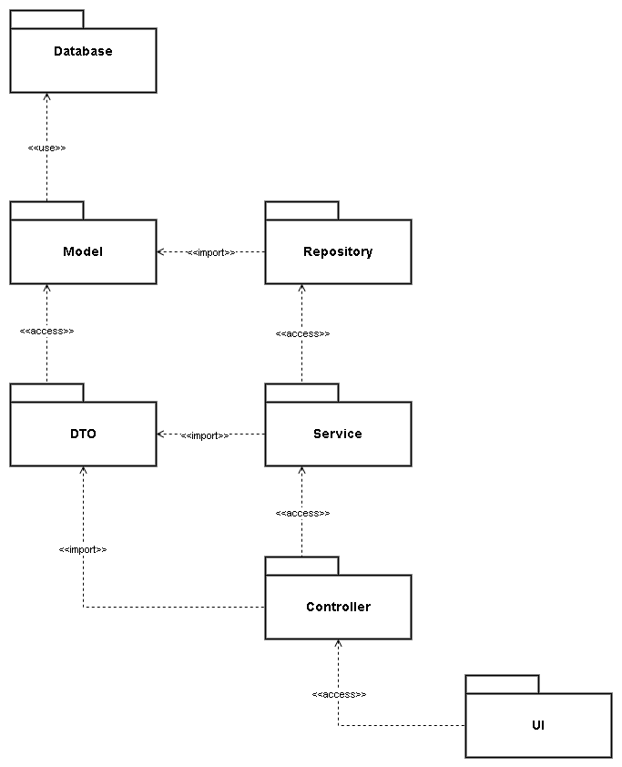

| **No** | **Package** | **Description** |
| --- | --- | --- |
| 01 | Database | Database Management System |
| 02 | Model | - Package of Data Access Layer  - Entity folder  - Having class context to connect with database  - Class name is the same as database table name (ex: Order.cs) |
| 03 | Repository | - Package of Data Access Layer  - Interacting with database server  - Separating Presentation and business logic  - Class name + Repository (ex: OrderRepository.cs) |
| 04 | DTO | - Package of Business Layer  - Passing data between Data and Presentation Layers  - Having class mappingConfig to map models with DTOs  - Class name + DTO (ex: OrderDTO.cs) |
| 05 | Service | - Package of Business Layer  - Handling conditions and logical operations  - Class name + Service (ex: OrderService.cs) |
| 06 | Controller | - Package of Presentation Layer  - API Endpoint  - Passing request to Business Layer and return response  - Class name + Controller (ex: OrderController.cs) |
| 07 | UI | - User Interface of Web Application |

### 5.2 ERD

[**Entity Relationship Diagram**](https://drive.google.com/file/d/1n0nT5ezLMhCyeiJMswisCM54O_EtvCbC/view?usp=sharing)

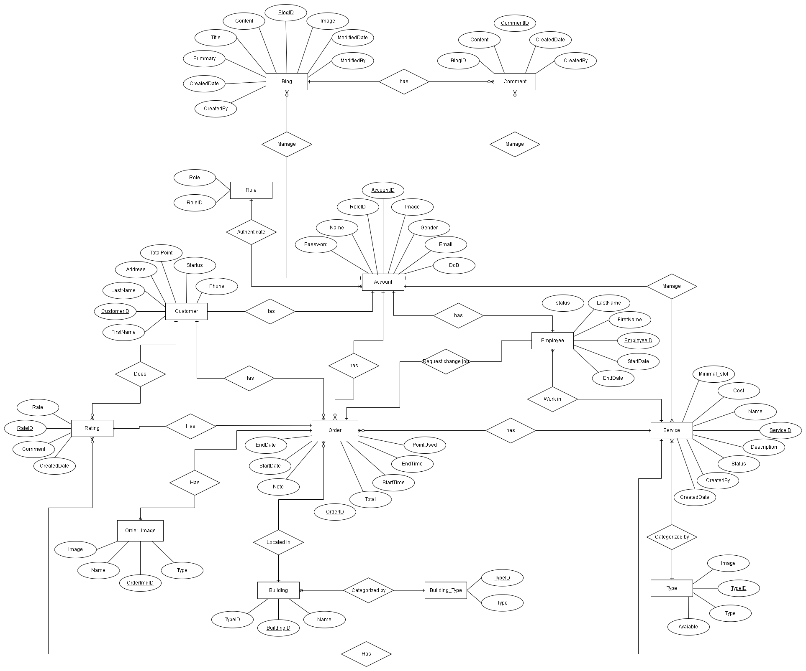

### 5.3 Database Schema

[**Database Schema**](https://drive.google.com/file/d/1OHbHOrHjV8qrlEqkWpqHEp0lQIHofSLe/view?usp=sharing)

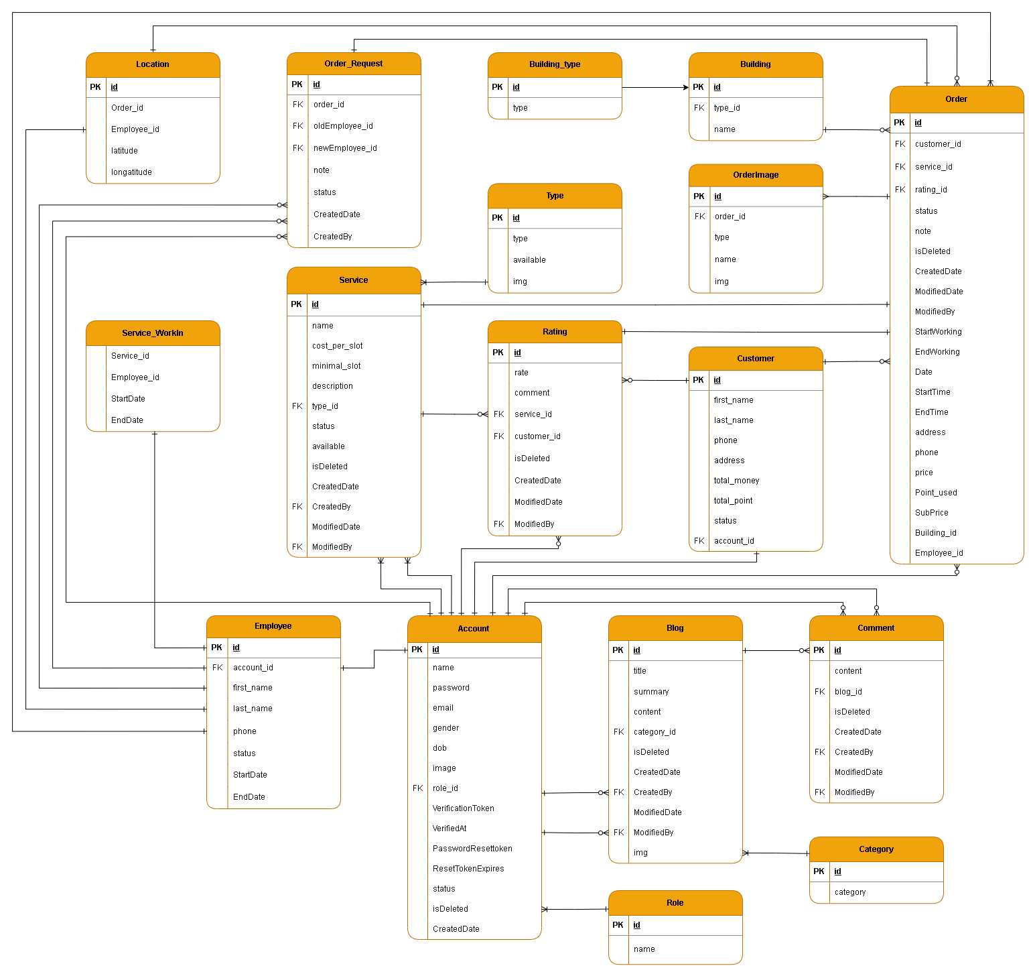

***Table descriptions & package class naming conventions are as below***

| **No** | **Table** | **Description** |
| --- | --- | --- |
| 1 | Account | - Primary keys: account_id  - Foreign keys: role_id  - Contains information of all accounts logged into the system |
| 2 | role | - Primary keys: role_id  - Assign roles to accounts such as manager, employee, customer |
| 3 | Customer | - Primary keys: customer_id  - Foreign keys: account_id  - Contains information about the customer |
| 4 | Employee | - Primary keys: employee_id  - Foreign keys: account_id  - Contains information about the employee |
| 5 | Service | - Primary keys: service_id  - Foreign keys: type_id, CreatedBy, ModifiedBy  - Contains detailed information about the services |
| 6 | Type | - Primary keys: type_id  - contains types of services |
| 7 | Process_Request | - Primary keys: id  - Foreign keys: process_id, employee_id, order_id  - Provide information |
| 8 | Order | - Primary keys: order_id  - Contains customer’s order information and processes it |
| 9 | Order_Detail | - Foreign keys: order_id, service_id  - Contains the service's details in order such as name, price,... |
| 10 | FinishedBy | - Foreign keys: order_id, employee_id  - Contains information of employee who finished his/her tasks in order |
| 11 | Process | - Primary keys: process_id  - Foreign keys: ModifiedBy  - Contains customer’s order information as a draft in which customer has not yet booked an order |
| 12 | Process_Detail | - Foreign keys: process_id, service_id  - Contains service’s details in the draft of the order for the customer such as name, price, description,... |
| 13 | ProcessImage | - Primary Keys: id  - Foreign keys: process_id, order_id  - Contains images captured by employees, which are sent to the customer after employees finished each service in process |
| 14 | WorkingBy | - Foreign keys: process_id, employee_id  - Contains information about the employees working in the current customer’s order |
| 15 | Rating | - Primary Keys: rate_id  - Foreign keys: service_id, customer_id, ModifiedBy  - Customer’s rating about the service that he/she booked before |
| 16 | Blog | - Primary keys: blog_id  - Foreign keys: category_id, CreatedBy, ModifiedBy  - Contains information of blogs created by the customer |
| 17 | Category | - Primary keys: category_id  - Contains kinds of blogs |
| 18 | Comment | - Primary keys: comment_id  - Foreign keys: blog_id, CreatedBy, ModifiedBy  - Contains information of customer’s comment in specific blog |

# USER MANUAL

### 1. Account

#### 1.1 Sign-up

* Function trigger: Click “Đăng kí” under login button
* Function description: This feature allows the actor to create a new account as public.
* Screen layout:

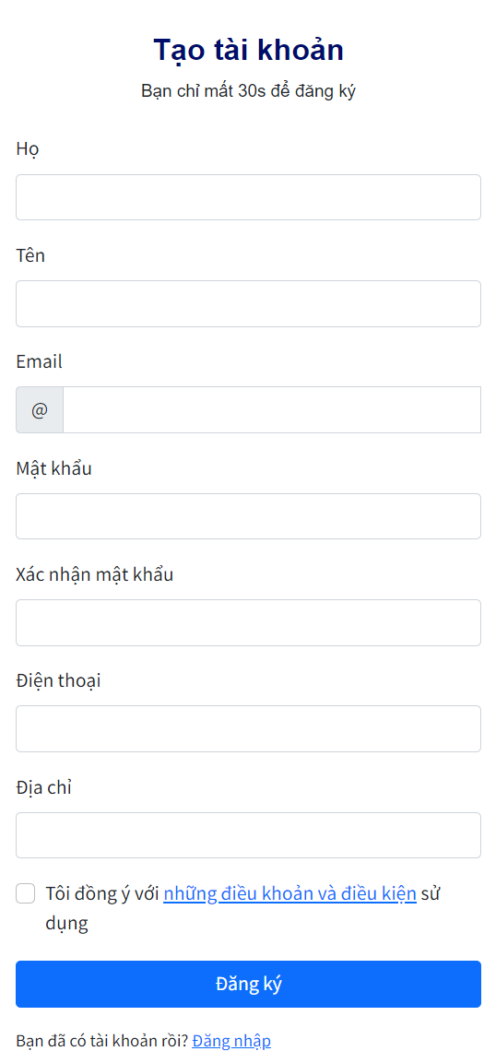

* Function Details:data(lastName,firstName,email, password, phone, address) business logics(Create new account).

#### 1.2 Login

* Function trigger: Click the avatar drop-down menu and then click “Thông tin cá nhân” on the navigation bar.
* Function description: Login to the system to use features related to each role.
* Screen layout:

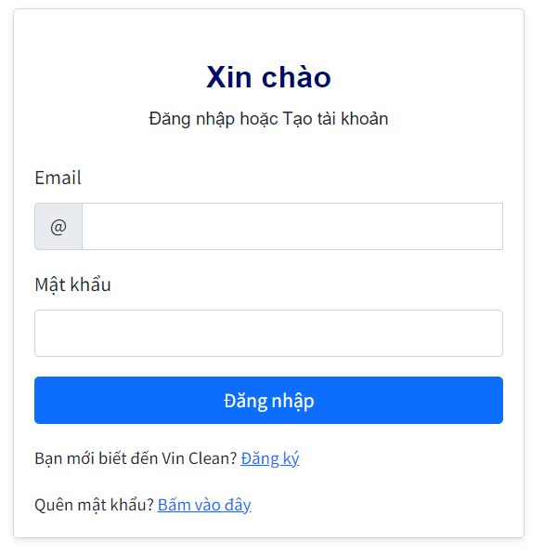

* Function Details:data(email, password) business logics(customer fills email and password and clicks “Đăng nhập” to login into the system).

#### 

#### 1.3 Logout

* Function trigger: Click the avatar drop-down menu and then click “Thông tin cá nhân” on the navigation bar.
* Function description: When customer clicks on “Đăng xuất” in the account, the system logs the actor out of current account.
* Screen layout:

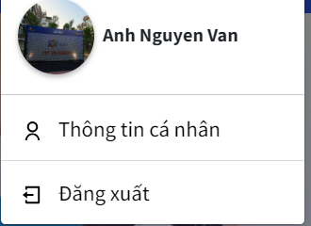

* Function Details: business logics (customer clicks ”Đăng xuất” to logout).

#### 

#### 

#### 

#### 1.4 Add employee account

* Function trigger: Click “Add employee” on the right top of employee account able
* Function description: This feature allows to create new employee account
* Screen layout:

#### 

Function Details:data(name, email, firstName, password,lastName, phone, gender, img), business logics (Create new employee account).

#### 1.5 Edit employee account

* Function trigger: Click the avatar drop-down menu and then click “Thông tin cá nhân” on the navigation bar.
* Function description:
* Screen layout:

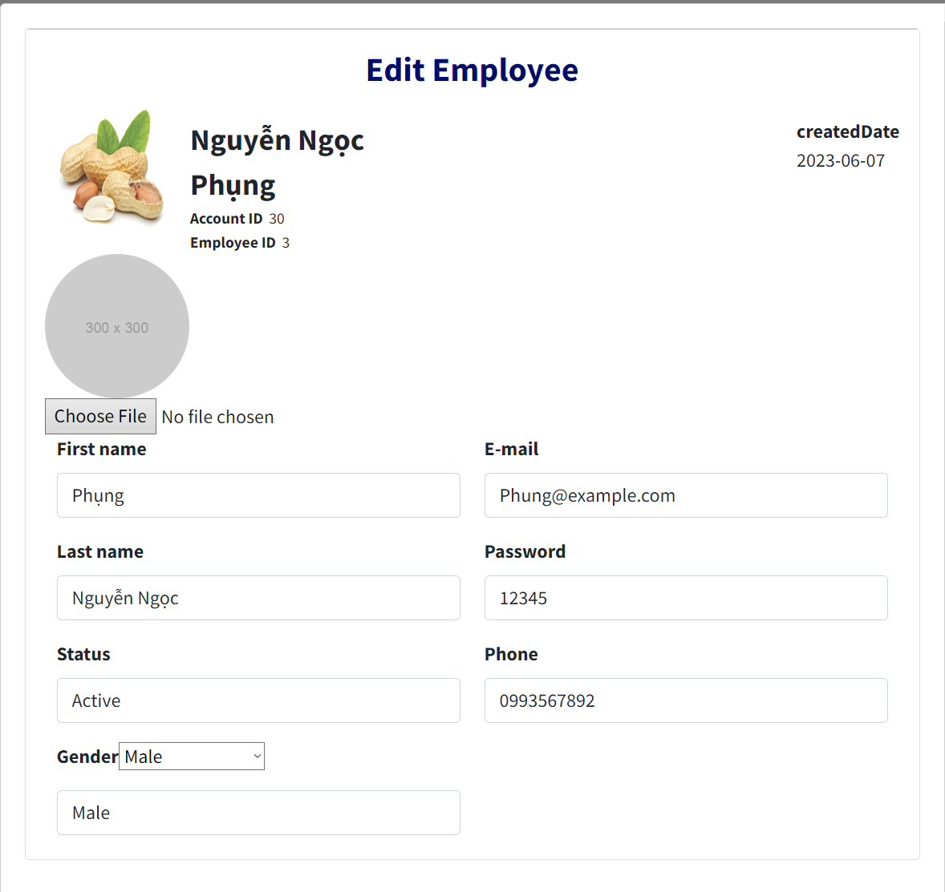

#### 1.6 View customer’s account list

* Function trigger: Click the “Customer” on the left sidebar.
* Function description: Overviews blogs and displays them in the blog page for the actor
* Screen layout:  
  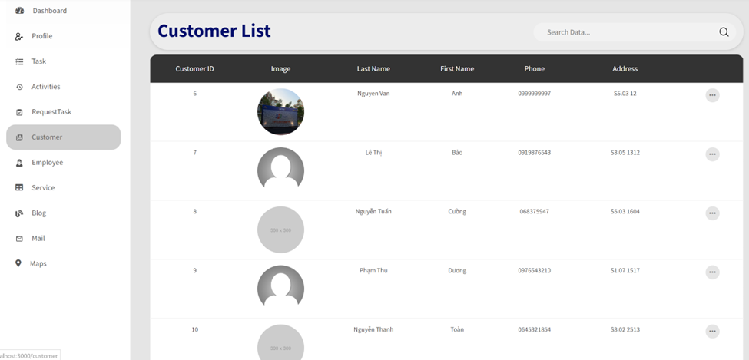

#### 1.7 View customer’s account details

* Function trigger: Click the “Xem thêm” on the blog card.
* Function description:
* Screen layout: 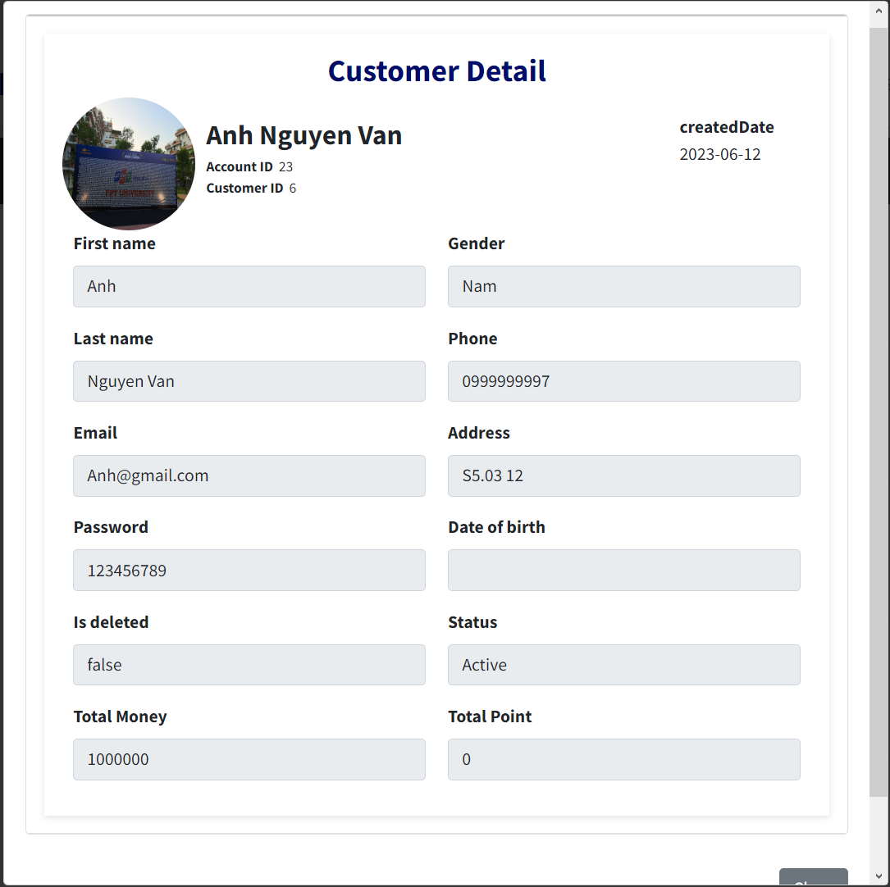

#### 1.8 View employee’s account list

* Function trigger: Click the avatar drop-down menu and then click “Thông tin cá nhân” on the navigation bar.
* Function description:
* Screen layout:  
  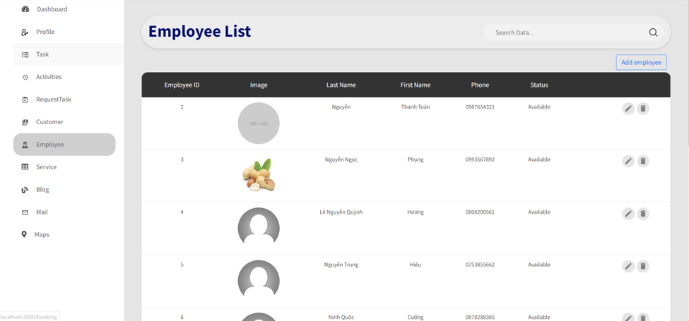

### 2. Service

#### 2.1 Get services cards

* Function trigger: Click the “Đặt dịch vụ” on the navigation bar.
* Function description: show each type of service for the actor to choose.
* Screen layout:

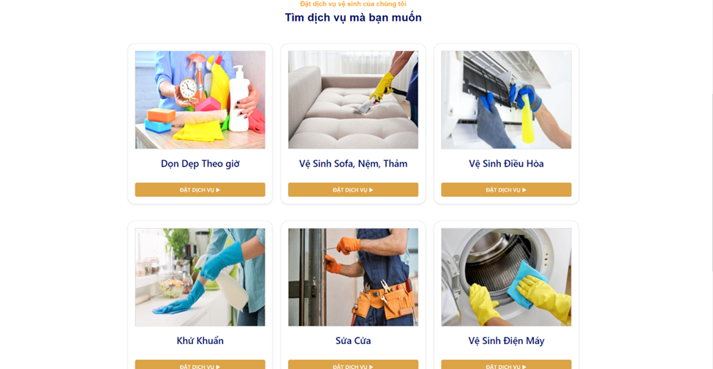

* Function Details: data(img, name) business logics(customer clicks “Đặt dịch vụ” to booking service)

#### 2.2 Get services details

* Function trigger: Click the “Đặt dịch vụ” on the service card.
* Function description: show clear information about the service like service, cost, slot, etc.
* Screen layout:  
    
  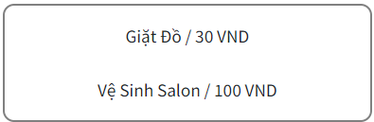
* Function Details:data (service,cost,slot),business logics (customer choose which service they want to choose and clicks ”Xác nhận”, the system pop-up details once more create new booking)

### 

#### 2.3 Book new service

* Function trigger: Click the “Đặt dịch vụ” on the service card.
* Function description: Show all the rating comment of the service type who actor choose
* Screen layout:

#### 

* Function Details:

#### 2.4 Get rating comment

* Function trigger: Click the “Đặt dịch vụ” on the service card.
* Function description: Show all the rating comment of the service type who actor choose
* Screen layout: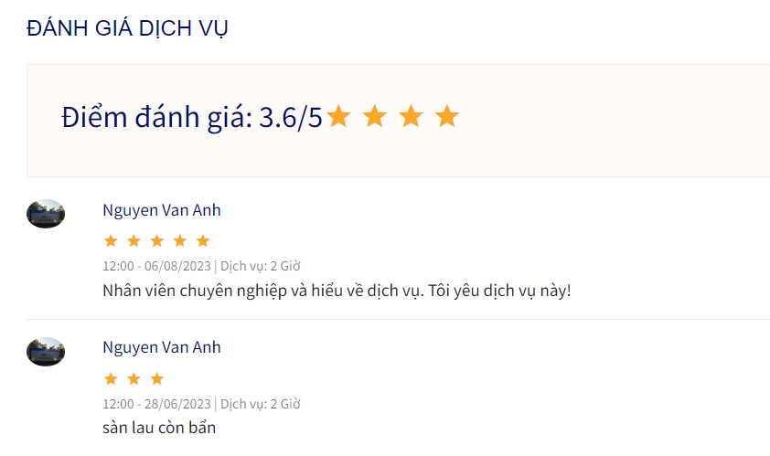
* Function Details: data(rating, name, createdTime, createdDate,serviceType, comment)

#### 2.5 Get service list

* Function trigger: Click the “Service” on the left sidebar.
* Function description: Show all service type.
* Screen layout:

### 

* Function Details: data(TypeId, type1, status, img),business logics(customer can change information about service type).

#### 2.6 Update service

* Function trigger: Click the Edit icon on the service panel.
* Function description: this feature allows manager to change information about service type.
* Screen layout:

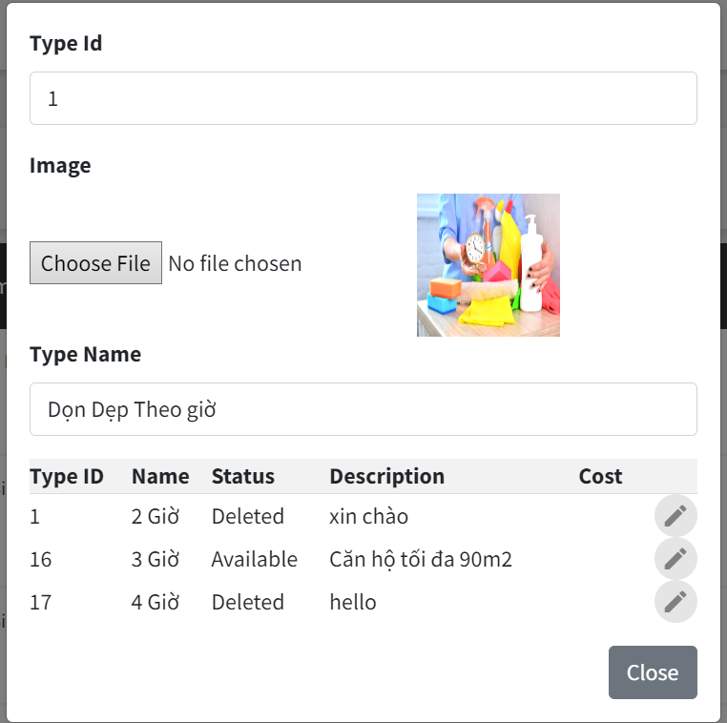

* Function Details: data(typeID, serviceName, status, description, cost), business logics(manager can chang serviceName, status , description and cost)

### 3. Blog

#### 3.1 Get blog cards

* Function trigger: Click the “Blog” on the navigation bar.
* Function description: Overviews blogs and displays them on the blog page for the actor
* Screen layout: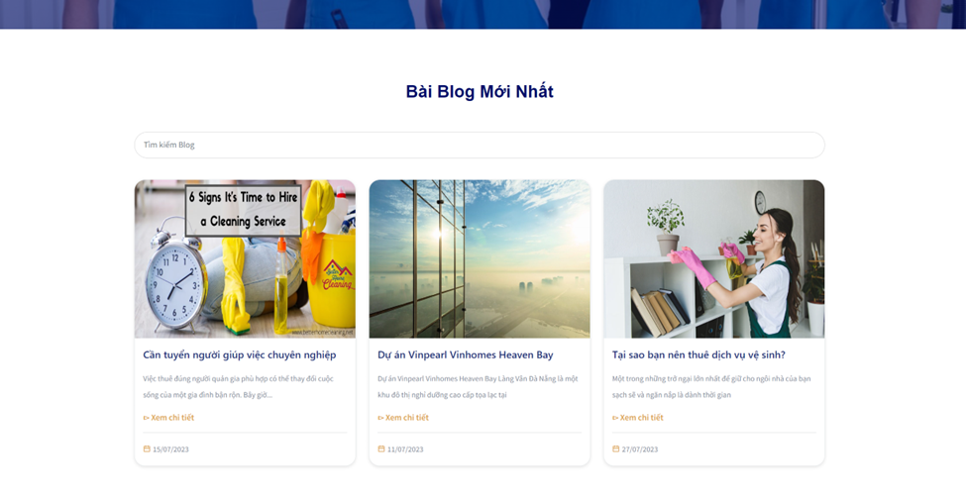
* Function Details: data (img, name, summary, createdDate), “Xem chi tiết” to show more details

#### 3.2 Get blog details

* Function trigger: Click the “Xem chi tiết” on the blog card.
* Function description: Redirects the actor to the blog chosen by the actor to read
* Screen layout:

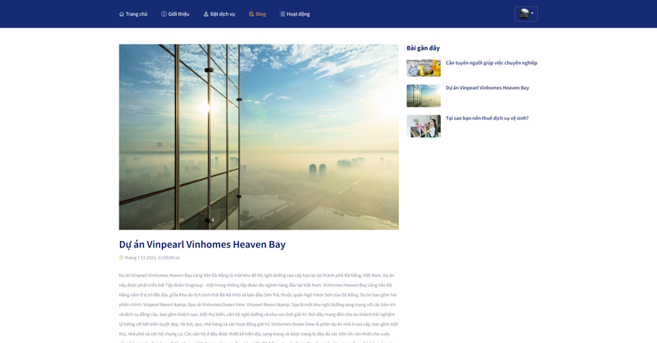

* Function Details: data (img, name, description, createdDate), “Bài gần đây” has a list of blogs (customer also clicks another blog to read).

#### 3.3 Get blog comments

* Function trigger: Click the “Xem thêm” on the blog card.
* Function description: Show all comments of blog that actor chose
* Screen layout: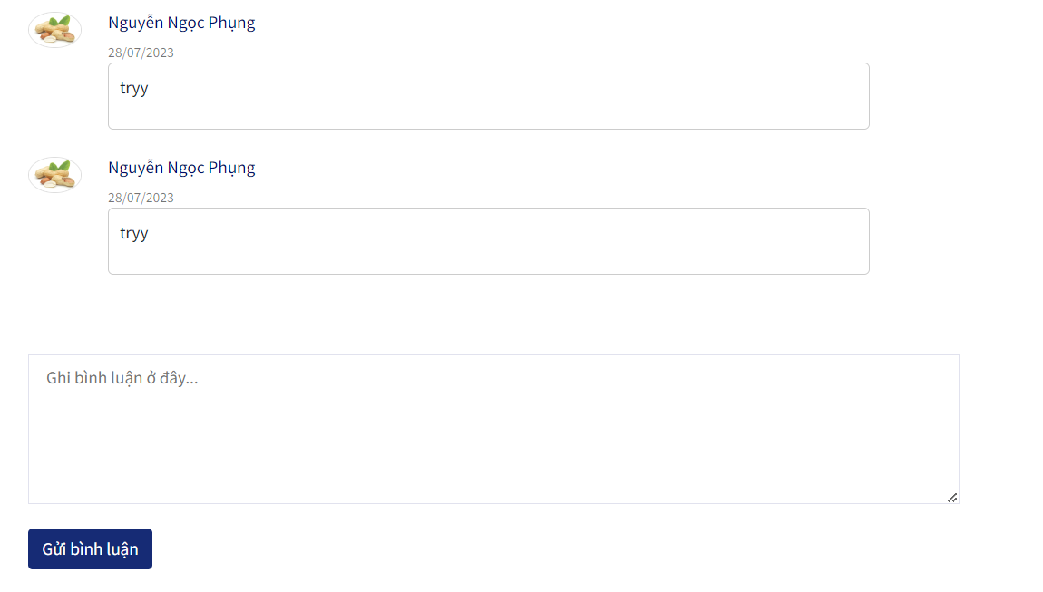
* Function Details: data(img, name, comment, createdDate), business logics(customer can write a comment and send).

#### 

#### 

#### 

#### 

#### 

#### 3.4 Get blog list

* Function trigger: Click the “Blog” on the left sidebar
* Function description: Show a list of blogs
* Screen layout:

#### 

* Function Details: data(blogId, title) business logics(manager can add, update and delete blog).

#### 

#### 3.5 Create blog

* Function trigger: Click the “Blog” on the left sidebar
* Function description: This feature allows manager to create a new blog.
* Screen layout: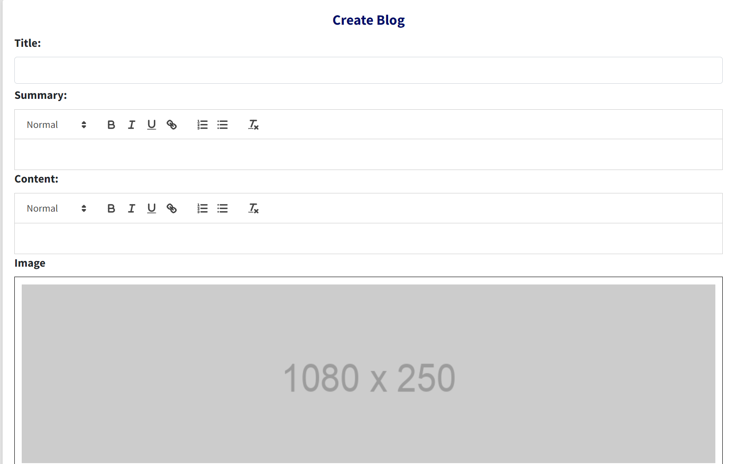
* Function Details: data(title, summary, content, image) business logics(create new blog)

#### 3.6 Update blog

* Function trigger: Click the “Blog” on the left sidebar
* Function description: This feature allows manager to create a new blog.
* Screen layout:

#### 

* Function Details: data(title, summary, content, image) business logics(update blog successfully)

### 4. Profile

#### 4.1 View customer profile

* Function trigger: Click the avatar drop-down menu and then click “Thông tin cá nhân” on the navigation bar.
* Function description: Show personal information of customer
* Screen layout:

View customer profile 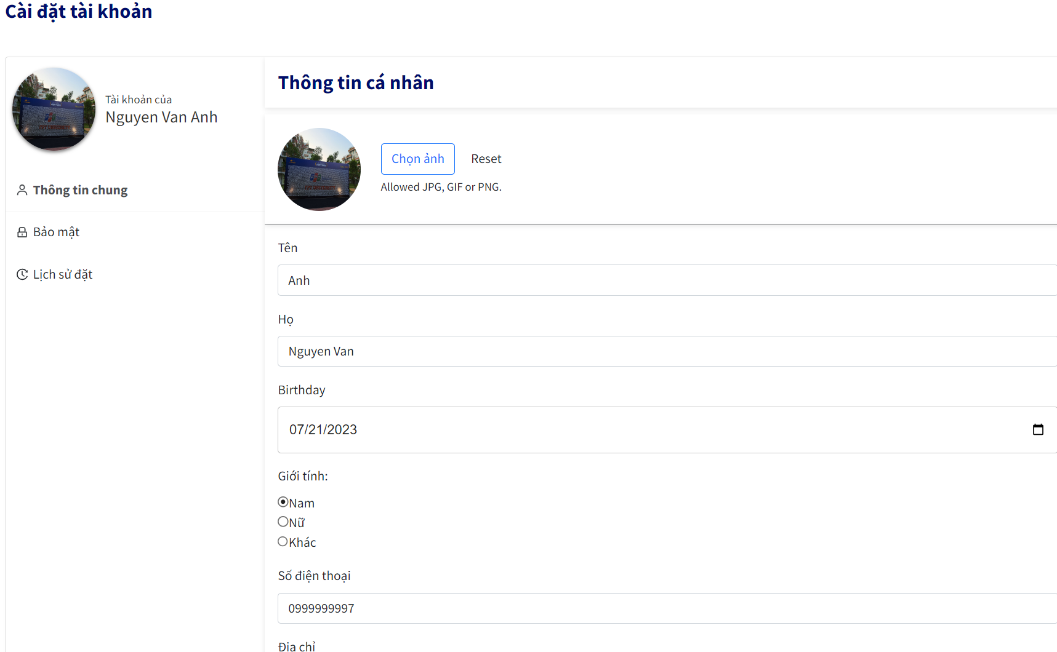Security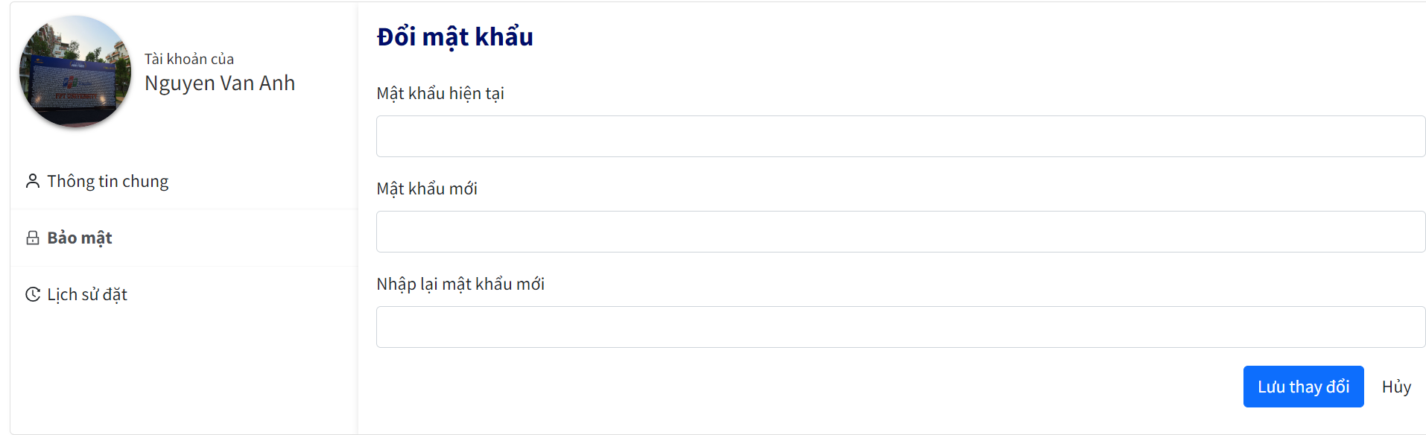

Booking History

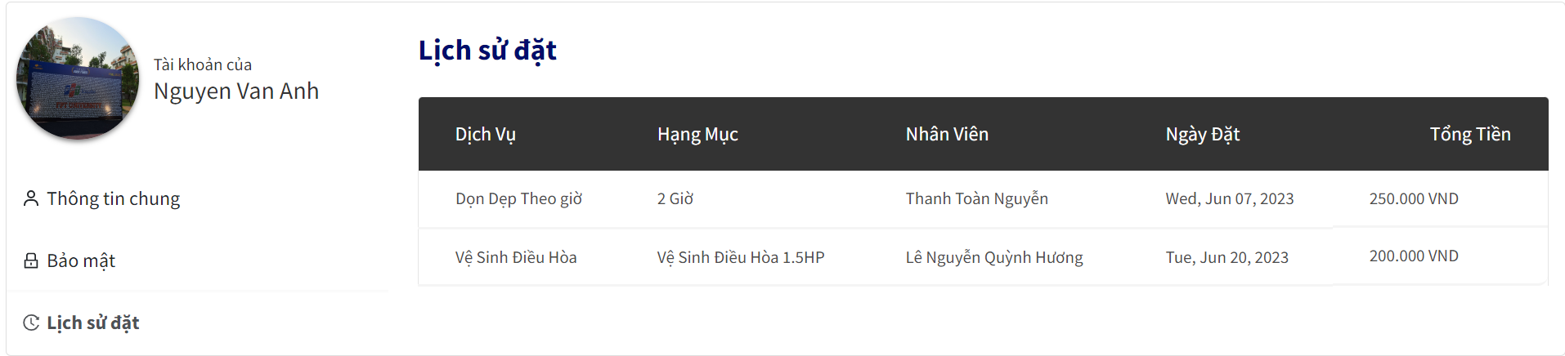Booking History Detail 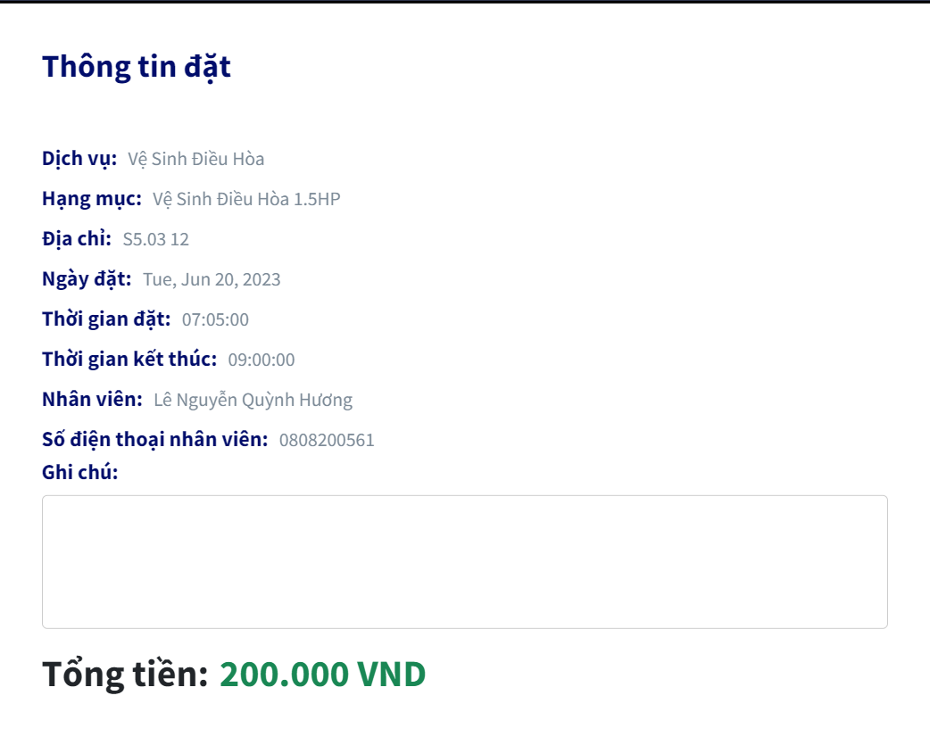

* Function Details: data(firstName, lastName, birthday, gender, phone, address; password; type1, serviceName, employeeName, createdDate, cost), business logics(customer can change password and view history booking to see details)

#### 

#### 4.2 View manager profile

* Function trigger: Click avatar on the navigation bar.
* Function description:
* Screen layout:

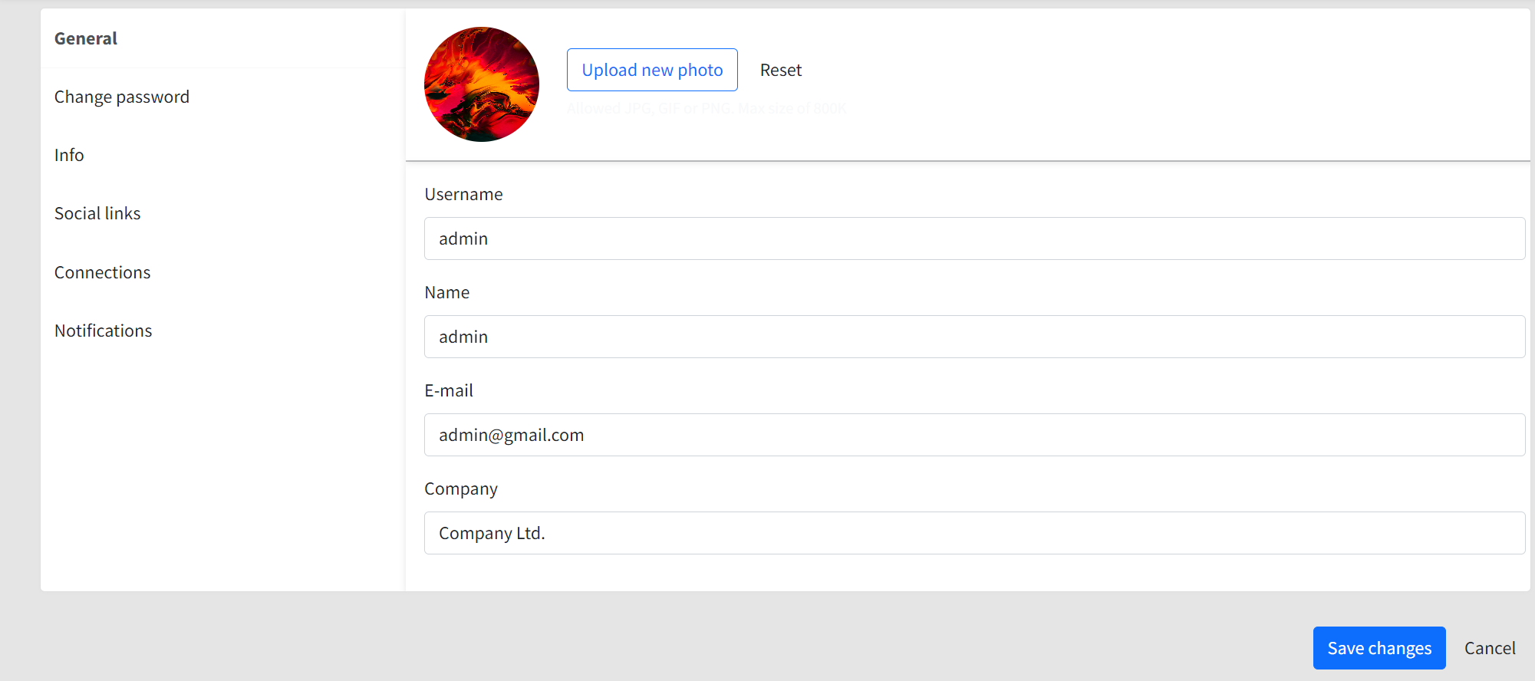

* Function Details: data(name, birthday, gender, phone, address; password; type1, serviceName, employeeName, createdDate, cost), business logics(manager can change password)

#### 4.3 View employee profile

* Function trigger: Click avatar on the navigation bar
* Function description: show personal information of employee
* Screen layout:

View profile employee  
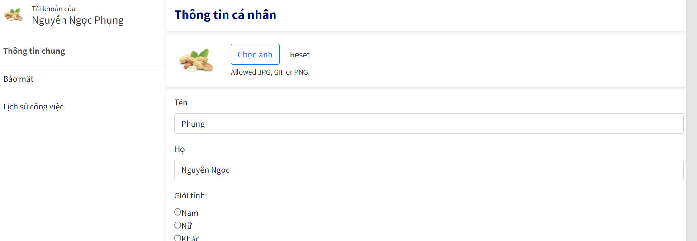

Employee security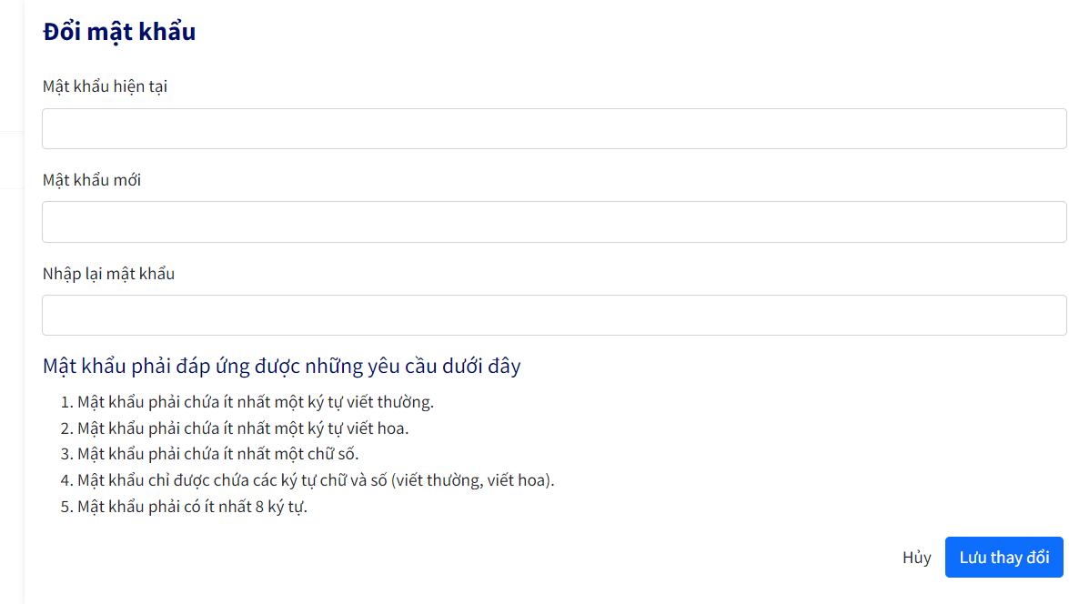

History job taken

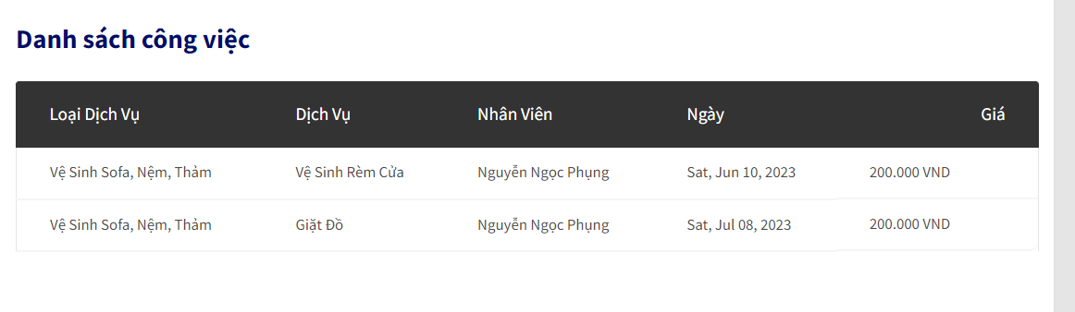  
History job details  
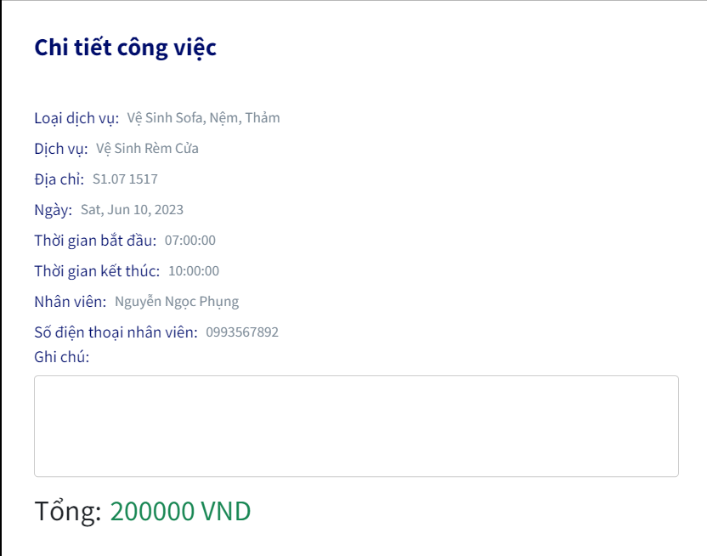

* Function details:data(firstName, lastName, birthday, gender, phone, address; password; type1, serviceName, employeeName, createdDate, cost), business logics(employee can change password and view history job taken to see details)

### 

### 

### 

### 

### 

### 

### 

### 

### 

### 

### 

### 

### 5. Order

#### 5.1 Get order list

* Function trigger: Click “Activities” on the left sidebar
* Function description: show all order list of customer
* Screen layout:

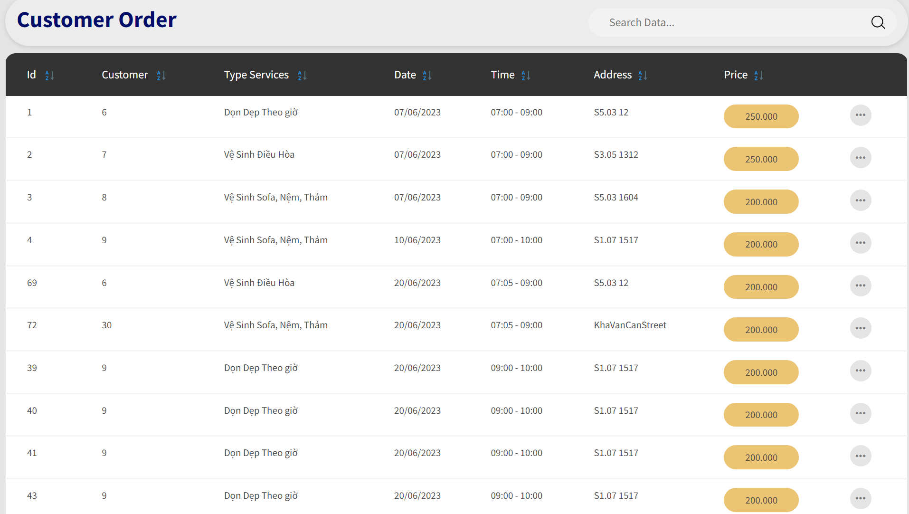

* Function Details: data(id, customerId, type, createdDate, createdTime, address, cost)

#### 

#### 

#### 5.2 Get order details

* Function trigger: Click Details icon on the table
* Function description: show details of customer’s order
* Screen layout:

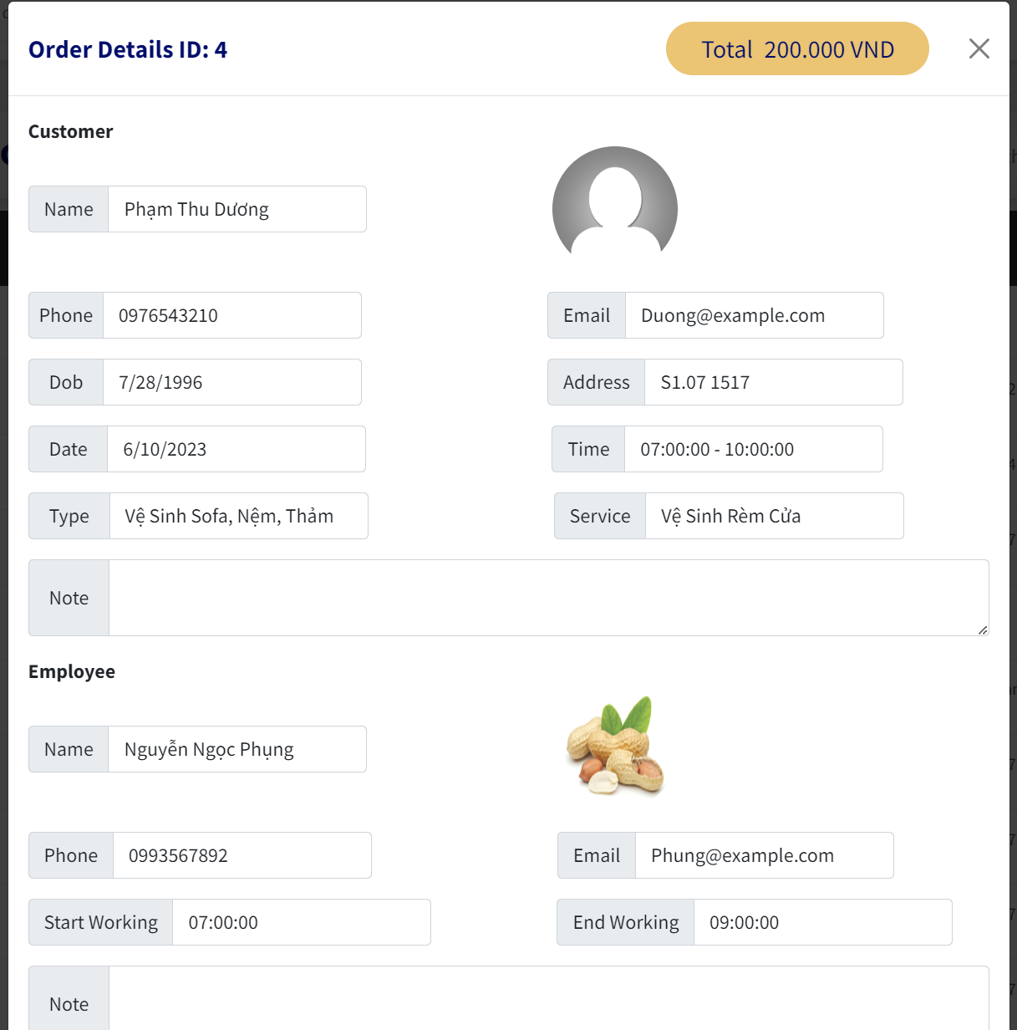

* Function Details: data(img, name, phone, email, createdDate, createdTime, type, service, startWorking, endWorking).

### 

### 6. Booking activities

#### 6.1 Get booking activity

* Function trigger: Click ”Hoạt động” on the navigation bar.
* Function description: Show all booking activities that customer has booked
* Screen layout:  
  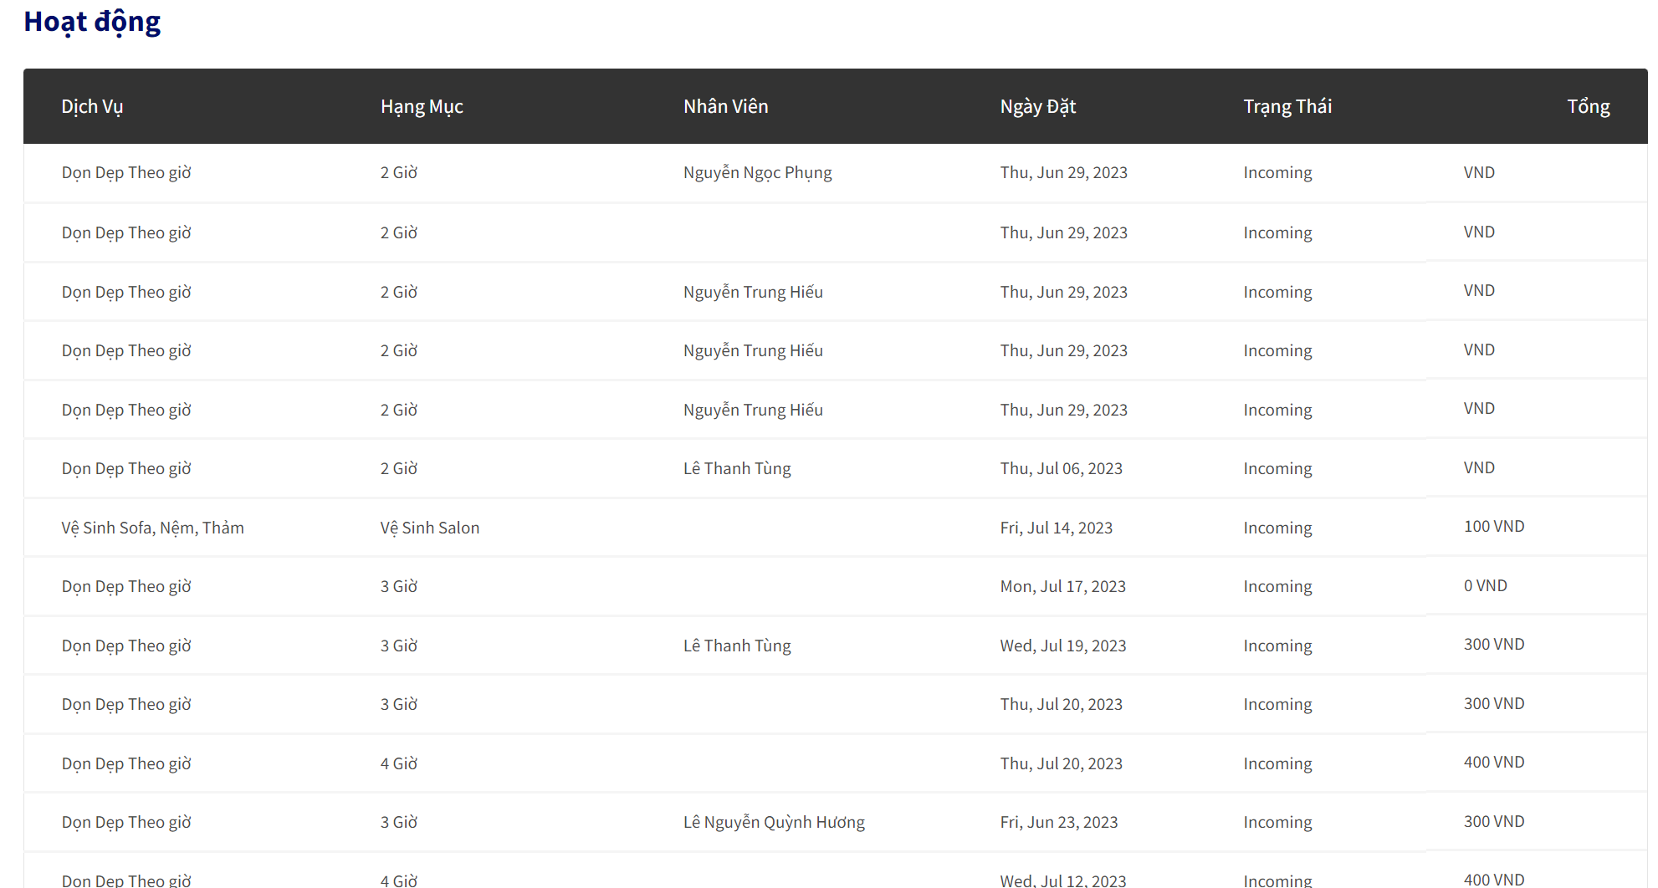
* Function Details: data(type, service, employee, createdDate, status, cost).

#### 

#### 

#### 

#### 

#### 6.2 Get booking details

* Function trigger: Click any activities panl that you booked on the table
* Function description: show details of service booking that customer has booked.
* Screen layout:

#### 

#### 

Incoming  
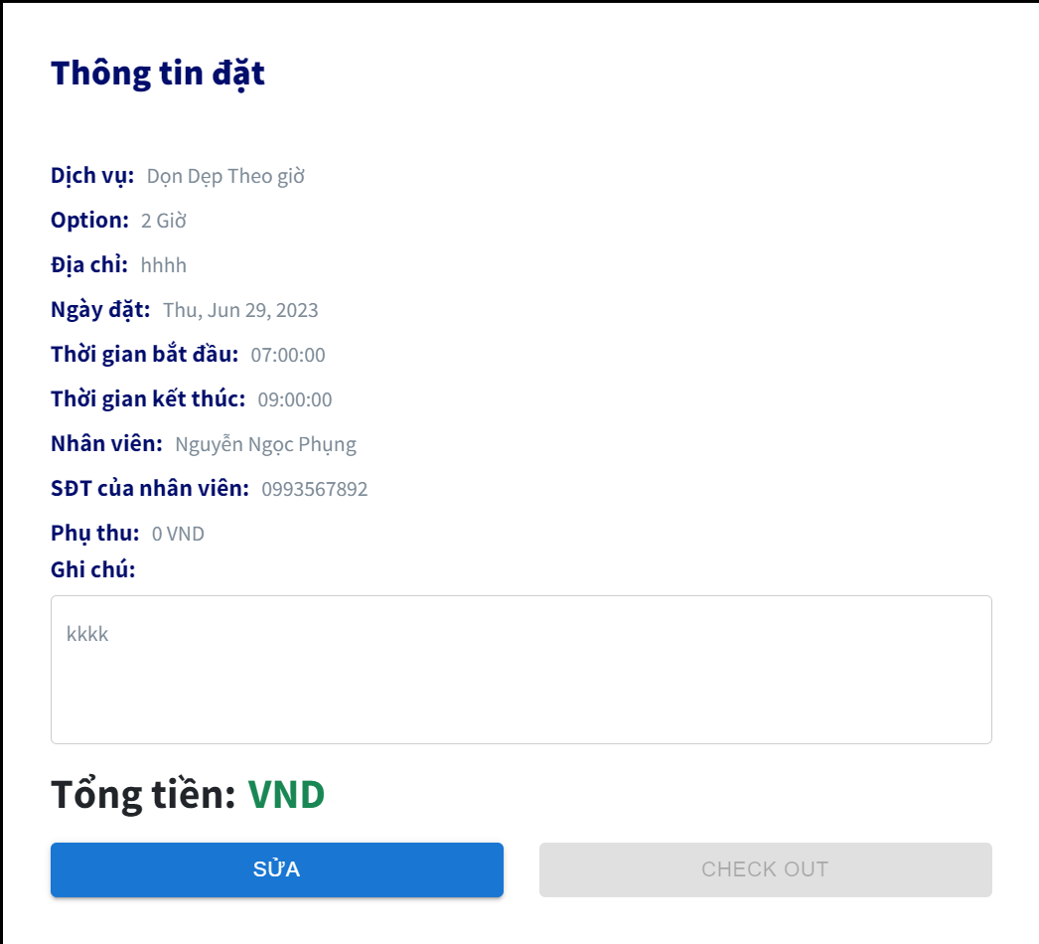

Processing

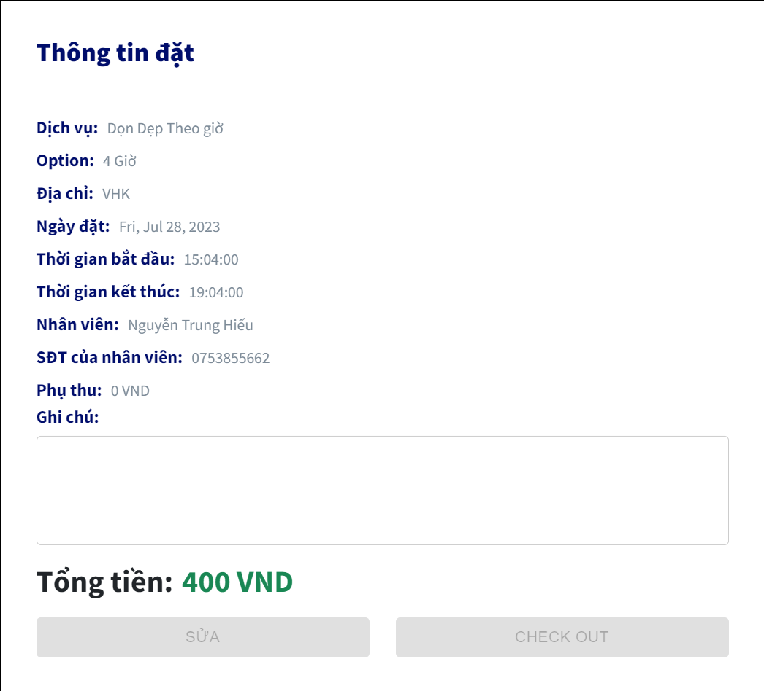  
Function Details: data(type, service, address, createdDate, startWorking, endWorking, name, phone,note )business logics()

#### 

#### 6.3 Get customer booking list

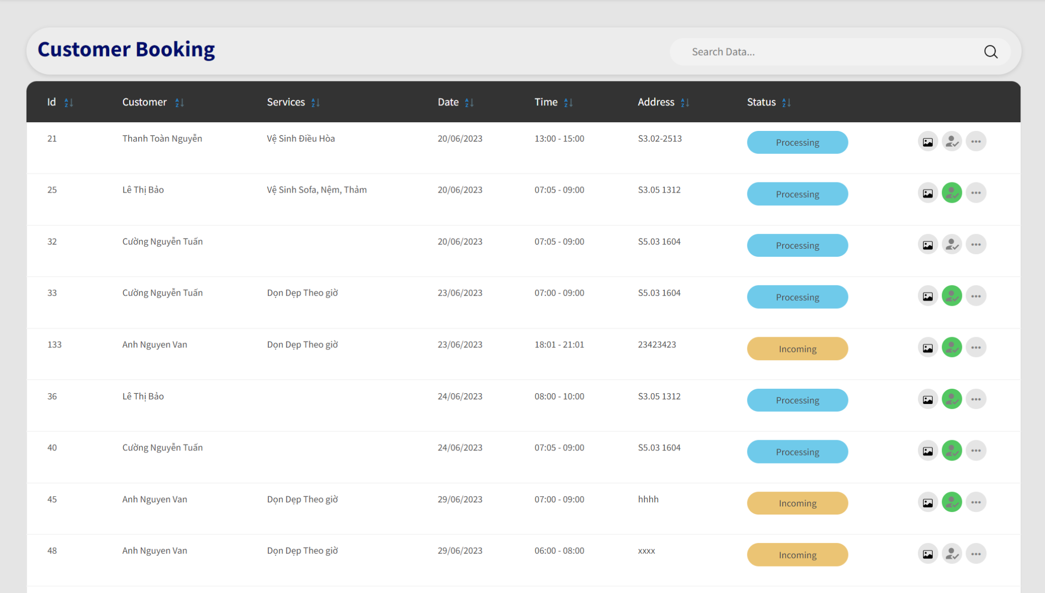

#### 6.4 Get customer booking details

#### 

### 7. Task

#### 7.1 View dashboard

* Function trigger: Click “Tổng quan” to view dashboard
* Function description: Show all job list, money that employee has taken before
* Screen layout:  
  View dashboard  
    
  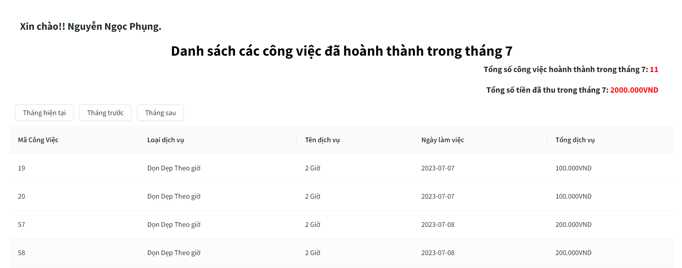  
  View dashboard details  
  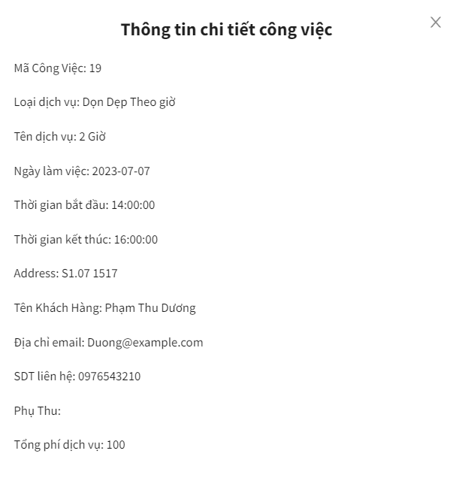
* Function Details: data(type, type1, createdDate, cost)

#### 7.2 View calendar

* Function trigger: Click ”Lịch công việc” on the navigation bar.
* Function description: Show all calendar that have details about job
* Screen layout:

#### 

Month  
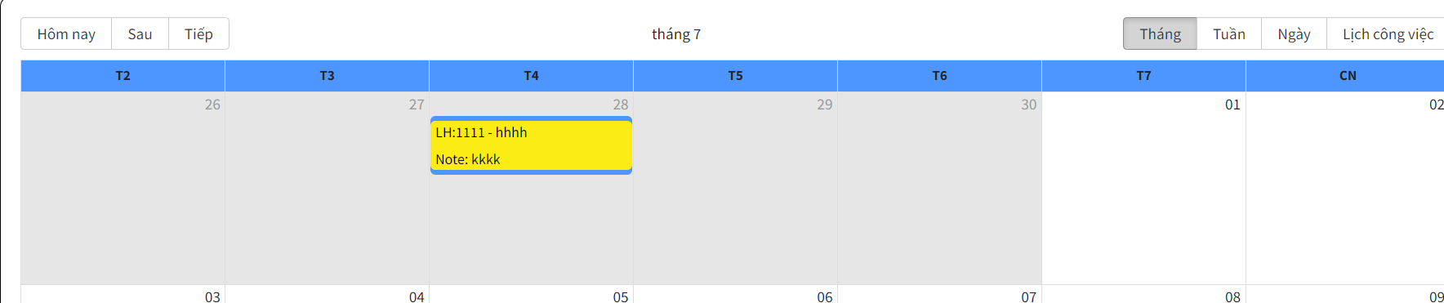

Week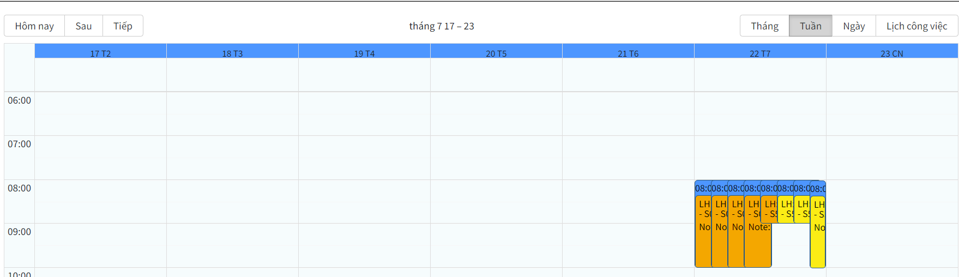

Day

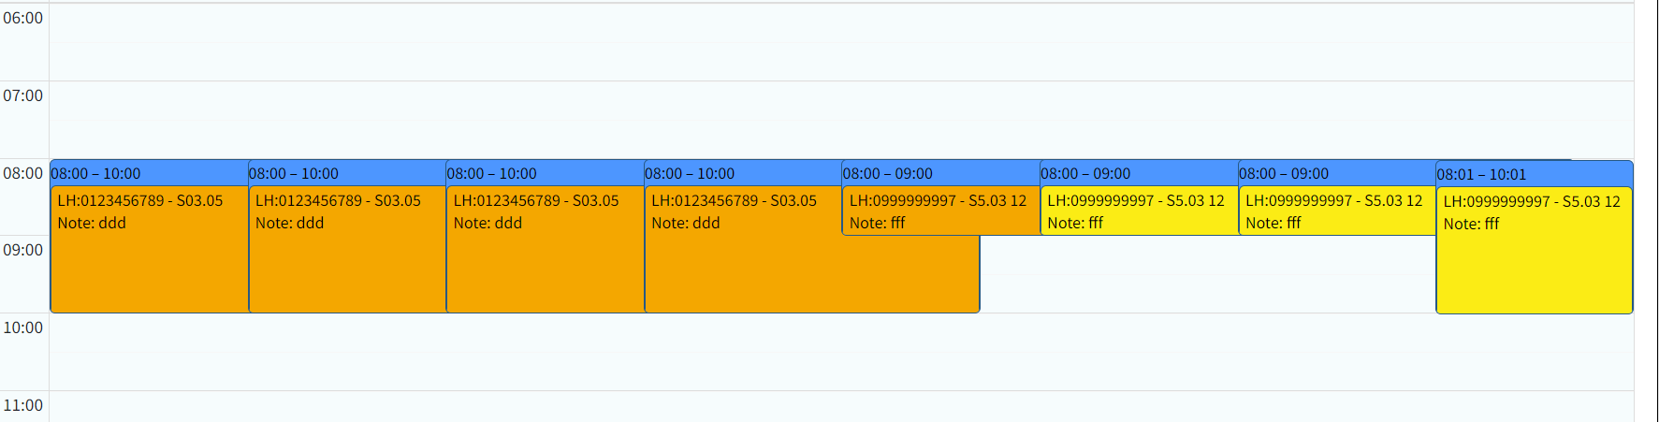

Job calendar

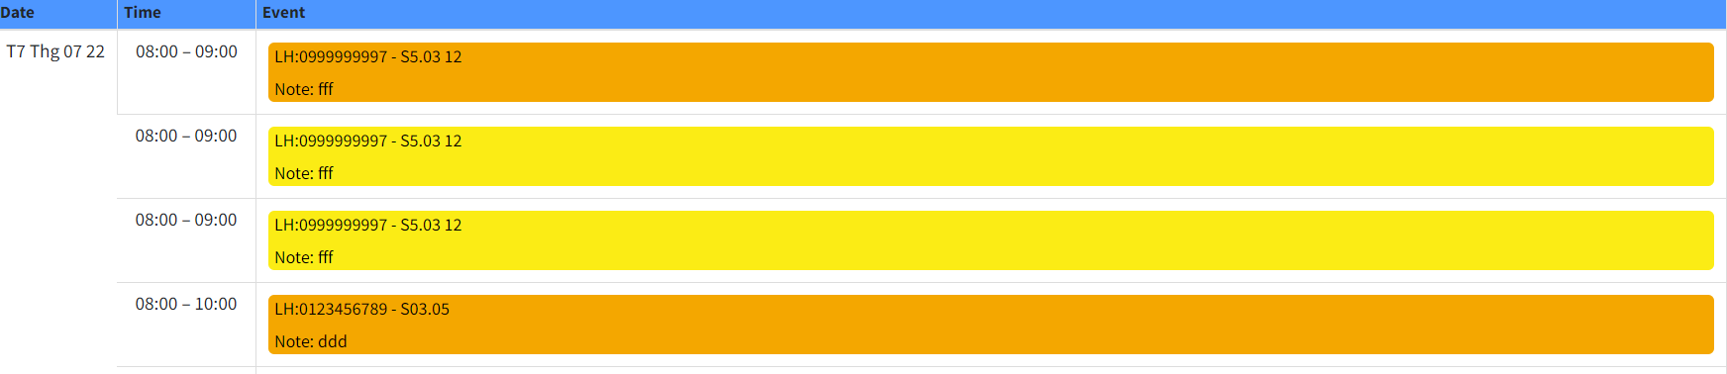

View job details

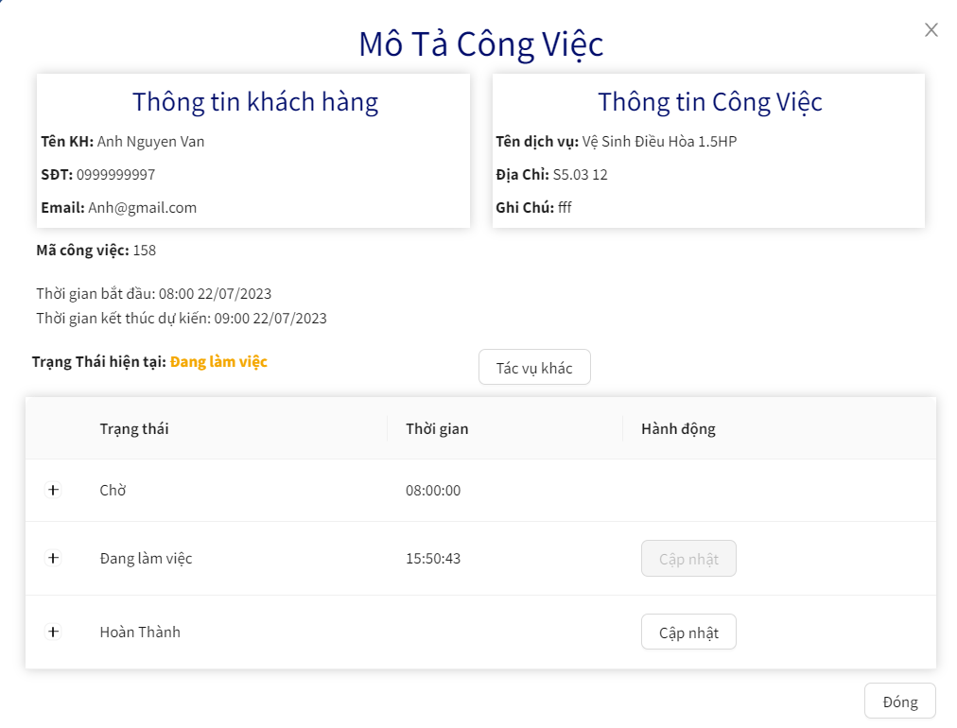  
View job task  
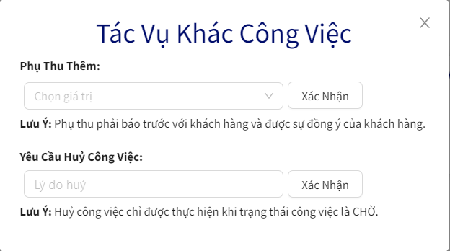

* Function details:data(customerName, phone, email; type, address, note; startWorking, endWorking; status, createdTime ), business logics(employee can take any job, see details of jobs, ask for the surcharge but asking customer first and also cancel job for personal reasons, if employee finishes his/her job, employee will update status to “Hoàn thành”)

Mental Health Website for Stress

* Chat with Staff (User can Chating Directly with Staff or AI bot - Combine ChatGPT): User có có thể chia sẻ những điều có nói và trò chuyện riêng tư nhất với nhân viên của website hoặc chatbot một cách thoải mái nhất
* Blog: Staff đăng những bài blog content về chữa lành để những user có thể tương tác và giao lưu.
* Podcast
* Diary: Nhật ký online dành cho User.

Personal Outfit Recommend Website for Men (Hiện tại thì Men sẽ phối đồ dễ hơn Nữ… và nếu ý tưởng này khả thi thì sau này sẽ mở rộng ra cho cả Women)

* Chat with Staff
* Blog
* Survey Test: Sẽ đưa ra những bức ảnh với những Style hiện đang phổ biến cho user chọn
* Hoặc là sẽ đưa ra những item mà người dùng đang có, ví dụ: Đang có áo thun, áo sơ mi, quần âu, quần ống rộng thì, giày basic… và người dùng chưa biết phối như thế nào thì  
  Người dùng sẽ lên chọn những item đang có sau khi chọn xong trang web recommend những kiểu phối liên quan
* Hiện tại mới chỉ là ý tưởng cơ bản như vậy thôi. Cần thảo luận thêm để đưa ra chức năng chính xác

Clothes Shop Website Combine Outfit Recommend ( Ý tưởng này sẽ là mở rộng của ý tưởng trên Khi làm một Website bán hàng kết hợp việc đưa ra những gợi ý outfit)

* Những ý tưởng ở Personal Outfit Recommend Website
* Và những chức năng cơ bản của website bán hàng online: Xem sản phẩm, đặt hàng, thanh toán…..